# Setup

Setup 1

System Requirements 2

New Processor Requirements 3

Installation Changes 4

Web Setup 4

Consumer-Friendly Installer 5

New Installation Options 6

Setup Flow: Setup Within Windows 11

Purchase Methods 11

Web Setup: Check Compatibility 12

Web Setup: Purchase 15

Web Setup: Obtain Product Key 23

Web Setup: Download 25

Web Setup: Start Setup or Create Install Media 27

Down-Level Phase 28

WinPE and First Boot 38

Windows Welcome 40

Setup Flow: Boot From Media 56

Dual Boot Configuration 60

Web Setup Details 62

Logging in Web Setup 63

Download Process 63

Creating Installation Media 64

Key Web Setup Paths 70

Troubleshooting 71

Web Setup Troubleshooting 71

Troubleshooting Other Issues 74

Upgrade Rollback 75

Choosing Migration Specifics 76

Migration Failures 76

Lab: Install Windows 8 77

Exercise: Upgrade 77

#### Timing for This Module

|  |  |
| --- | --- |
| Delivery Length: 120 Minutes | Additional Lab Time: 90 Minutes |

#### Overview

This module examines the installation process for Windows® 8, including a walkthrough of the installation process, changes in this release compared with Windows 7, and troubleshooting implications of those changes.

## System Requirements

The system requirements for Windows 8 generally match those for Windows 7. There is a change in processor requirements, and some additional requirements for new features in Windows 8.

Table : System requirements

|  |  |
| --- | --- |
|  | **Requirement** |
| **Processor** | 1 gigahertz (GHz) or faster with PAE and SSE2 support. See New Processor Requirements topic below for details. |
| **RAM** | 1 gigabyte (GB) (32-bit) or 2 GB (64-bit) |
| **Hard disk space** | 16 GB (32-bit) or 20 GB (64-bit) |
| **Graphics card** | Microsoft DirectX® 9 graphics device with WDDM driver |

Additional requirements to use certain features:

To use touch, you need a tablet or a monitor that supports multitouch.

For more information about touch requirements for Windows 8, please see the following post on the Windows 8 blog:

**Touch hardware and Windows 8**  
<http://blogs.msdn.com/b/b8/archive/2012/03/28/touch-hardware-and-windows-8.aspx>

To be able to run Windows Store apps, you need a screen resolution of 1024 x 768.

To snap apps, you need a screen resolution of at least 1366 x 768.

### New Processor Requirements

In order to install Windows 8, your **CPU must now support PAE, NX and SSE2.** Some CPUs support these features, but have them disabled in the BIOS. In many cases, Windows 8 can handle enabling this feature automatically, but it may be necessary to have the customer verify this in the BIOS.

If you use the new Web Setup method to install Windows 8 on a PC with a processor lacking PAE or SSE2 support, you will see the following message.

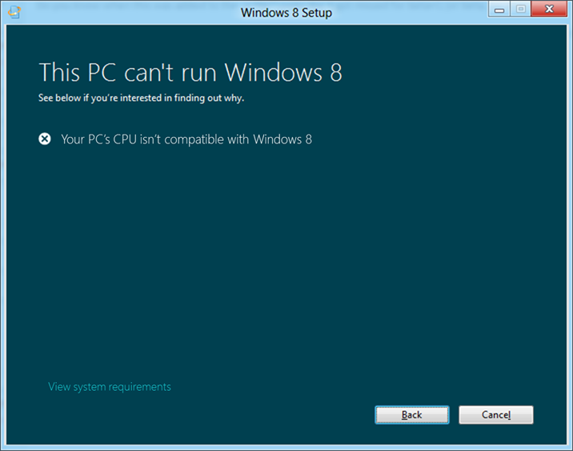

Figure : CPU compatibility message

If your CPU supports NX but it is disabled, setup will attempt to enable it during the installation. If this fails for some reason, you will see the following STOP error:

STOP 0x0000005D UNSUPPORTED_PROCESSOR

If this is encountered during an upgrade setup will rollback to your previous OS configuration. In clean installations you may need to use the Windows.old folder to restore the previous operating system. This scenario is discussed in the “Processor Compatibility Issue” topic later in this module.

#### Verifying CPU Features

If you encounter this error when trying to install Windows 8, you can use the Sysinternals tool Coreinfo to determine the features that your CPU supports. It is available for download from TechNet:

<http://technet.microsoft.com/en-us/sysinternals/cc835722>

If the CPU supports PAE and SSE2, it is possible that PAE has been disabled in the BIOS configuration and cannot be enabled automatically by Windows. Check with the PC or motherboard manufacturer for guidance on enabling the features needed to support Windows 8.

## Installation Changes

Windows 8 introduces several changes to the installation process. These mainly impact what you see when you start the installation from within Windows. Changes include the following:

* **Web Setup -** This new feature makes it easier to purchase Windows online. With Web Setup, the Upgrade Assistant interface handles the details of downloading the Windows 8 installation files, and providing the product key to setup automatically.
* **Consumer-friendly installer -** Windows 8 includes a more consumer-friendly setup interface, provided by install.exe in the installation media.
* **New installation options -** Windows 8 presents you with 3 clear options for setup. Unlike the **Upgrade** and **Custom** options in earlier releases, the new choices provide clearer guidance on the outcome.

### Web Setup

Web Setup – also known as Electronic Software Distribution (ESD) – is the new method for purchasing, downloading, and installing Windows. In earlier Windows releases, when you download a Windows installation source, it arrives as an .ISO disk image file that must then be burned to a disc before setup can be started.

With Web Setup you can download the small Upgrade Assistant interface directly from the Windows 8 download page. This interface guides you through the steps to get Windows and install it. There are several other key benefits:

* Upgrade Assistant includes a compatibility check, similar to the Upgrade Advisor in previous Windows releases. This compatibility check is run automatically and will show information on things like DVD playback and secure boot, as well as links to more information or third party sites for updates. The report provided is informational to show details on program and PC compatibility – no user action is required.
* Architecture and language selection is automatic.
* Product purchase offers are made based on the current Windows installation, market, and your choice of installation option.
* The download is done using the Windows Background Intelligent Transfer Service (BITS). This helps ensure a resilient download, which can be paused and resumed as needed.
* The online service for the download also provides your product key to Web Setup. Web Setup in turn passes the key to install.exe. This eliminates the need to type in the product key during setup.
* Option to create an ISO file or bootable flash drive for use to install on another PC or another partition.

Once the Upgrade Assistant completes all Web Setup actions, you will have a downloaded installation source that can be used to start installing immediately or it can be used to start it later. If you choose to start the installation later, there will be an “Install Windows” shortcut on the desktop to make that easier.

Web Setup via Upgrade Assistant is the recommended path for downloading and installing Windows 8 unless you must change Windows architecture or language versions from the current installed operating system, or install to a different partition.

Web Setup is covered in more detail later in this module.

### Consumer-Friendly Installer

The experience when starting setup from a down-level operating system has changed dramatically for Windows 8. Windows Vista® and Windows 7 used a Setup.exe based installer that was intended to be a one-size-fits-all solution, which meant that the core functionality could be used in multiple scenarios, such as "Boot from media," "Start from down-level," and even corporate scenarios like using Windows Deployment Services. This is changing for Windows 8.

A new installation process has been introduced that is targeted specifically for consumer retail scenarios where the installation was started from a down-level Windows operating system. This is in addition to the Web Setup functionality.

When setup is initiated by inserting a DVD or USB key with the installation media, the Autorun.inf on the installation media points to a Setup.exe file on the root of the media, but this Setup.exe is just a small file that performs the following actions:

* Sets up of the operating environment for Install.exe
* Launches Install.exe from the \Sources folder

**Note:** Launching install.exe directly is not supported. It must be run launched by the Setup.exe file at the root of the media.

Customers will begin setup with the Install.exe setup experience only when starting setup from an existing installation of Windows. When booting from a DVD or USB drive, the legacy Setup.exe installer is used. This legacy Setup.exe is stored in the \Sources folder on the installation media.

Other documentation may refer to the two different types of setup as Setup and Advanced Setup.

* **Setup:** This is the method of installing Windows that is started from down-level and uses install.exe. This version is what will be used by the majority of consumers installing their own copy of Windows over an existing down-level copy of Windows.
* **Advanced Setup:** This is the method of installing Windows that is started by booting from the DVD or USB flash drive. This method supports selecting the installation partition and using switches to control the behavior of setup.

#### Install.exe Actions

Install.exe is responsible for guiding you through the initial wizard where information like the following is gathered and actions performed:

* **Dynamic Update:** Similar to previous Windows setup processes, Windows 8 setup is capable of connecting to Windows Update and downloading any updates to the setup process prior to beginning the installation. You have a chance to opt-in to this.
  + This setting is presented as "Get the latest, these updates to Windows Setup will help make the installation smoother." The choices you see are either "Go online to install updates (Recommended)" or "No thanks".
  + If you are installing using Web Setup, Dynamic Update is always enabled.
* **Customer Experience Improvement Program (CEIP):** Selecting this option will send information about the success or failure of the Windows Setup process back to Microsoft for analysis. This is enabled by default, but you can opt out:
  + This setting is shown on the "Get the latest" screen where dynamic update was configured. The checkbox option has the text "I want to help make the installation of Windows better". This option is enabled by default.
* **End User License Agreement (EULA):** You must agree to the EULA when prompted in order to proceed with setup. The Accept button is disabled until you select the checkbox option for "I agree to the license agreement".
* **Product Key:** A product key is required for installation of Windows 8. Depending on how setup is started, this option may be skipped. When you start setup using Web Setup the key is provided to Install.exe automatically.

### New Installation Options

When you start Setup within Windows using Web Setup or the new, default, Install.exe method, you will have clear options for migration of apps, settings, accounts, and data. An example of these options is shown below. The specific options provided will vary depending on your starting Windows version.

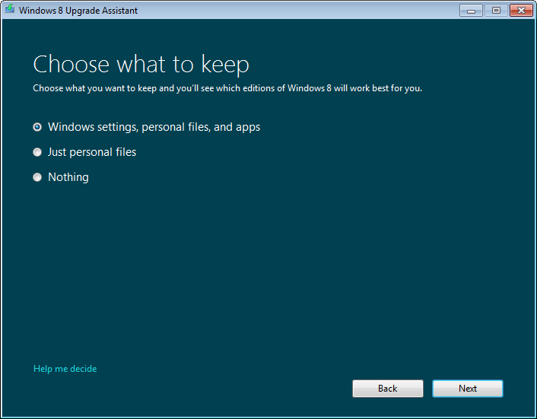

Figure : Windows 8 Consumer Preview―choosing what you want to keep

This is the replacement for the two options that were provided in Windows 7 – Upgrade and Custom Installation. These options will still appear in the setup.exe interface. You will see this when setup is started by booting from the Windows 8 installation media.

The new migration options are listed in the following table.

Table : What is kept when upgrading to Windows 8

|  |  |  |
| --- | --- | --- |
| **Migration Option** | **Description** | **Supported when starting from:** |
| Windows settings, personal files and apps | **Upgrade**  This option migrates everything. It is the equivalent of an upgrade installation on Windows 7. | * Windows 8 * Windows 7 |
| Windows settings and personal files | **Migrate Settings and Data**  This performs a clean install with migration of user accounts, files and settings in the current Windows installation. This is similar to using Windows Easy Transfer with a clean install. | * Windows Vista SP1+ |
| Just personal files | **Migrate Data**  This performs a clean install and migrates only user accounts and files for users currently configured in Windows. | * Windows 8 * Windows 8 Release Preview * Windows 7 * Windows Vista * Windows XP |
| Nothing | **Migrate Nothing**  This option performs a clean install. | * Windows 8 Consumer Preview, Developer Preview * Windows XP and all later versions |

**Warning:** If you create installation media, start your PC from the media, and then install Windows 8, you won't be able to keep your files, programs, or settings. To keep files, programs, or settings you need to start your installation from within Windows.

All of these options include a compatibility check to help ensure that there are not blocking issues that would prevent Windows 8 from being successfully installed on the target PC. Setup is not blocked in situations where Windows 8 can be installed successfully. The focus is on providing information on these issues and letting setup proceed.

If setup is blocked for a more serious issue and needs to be restarted after addressing a blocking scenario, it will remember any information that was already entered or selected, such as the product key, End User License Agreement (EULA), and Customer Experience Improvement Program choice.

After providing the requested information, setup will proceed and reboot multiple times, first into WinPE phase and then into First Boot phase. After finishing the installation, you will see the Windows Welcome interface.

Each of these options is examined in more detail below.

#### Upgrade

In Windows 7 terms this an “Upgrade Installation”. The option to migrate everything is available when installing from Windows 7 or when installing Windows 8 over itself as an in-place upgrade.

The Migrate Everything installation proceeds in these steps:

1. User accounts, data files, settings and apps are collected.
2. The previous installation is moved to a Windows.old directory.
3. A clean installation is performed.
4. The previously-gathered user accounts, data files, settings and apps are applied to the new installation.

This is done in generally the same way as on Windows 7, except for step 2. The Windows.old folder was only created during a clean installation of previous Windows versions. Windows 8 uses this folder for the app and data migration rather than the previous temporary folder paths.

This is great news from a troubleshooting standpoint. It means that if there is an issue with migration, you can use this folder as a source for recovering files.

##### Upgrade Paths

The supported paths for upgrade installations to Windows 8 are shown in the table below. As with previous Windows versions, the language of the current installation must match the language of Windows 8 in order to support upgrade. Migration options are provided cross-language.

The table uses the following values:

* **Yes:** Upgrade path.
* **Mig:** Setup offers to migrate files, or files and settings.
* **FP:** There is a feature pack you can install for this path.
* **-:** No migration path.

Table : Windows 8 upgrade paths

|  |  |  |  |
| --- | --- | --- | --- |
| **Upgrade From:** | **Windows 8** | **Windows 8 Pro** | **Windows RT** |
| Windows XP SP3+ | Mig | Mig | - |
| Windows Vista SP1+ | Mig | Mig | - |
| Windows 7 Starter, Home Basic, Home Premium | Yes | Yes | - |
| Windows 7 Professional, Ultimate | Mig | Yes | - |
| Windows 8 Release Preview | Mig | Mig | - |
| Windows 8 | Yes | FP | - |
| Windows 8 Pro | Mig | Yes | - |
| Windows 8 RT | - | - | - |

In Windows 7 you can move between editions with Windows Anytime Upgrade (WAU). Windows 8 uses a similar mechanism – feature packs. This is discussed in the “Add Features to Windows 8” topic in the Activation module of this course. Because Windows 8 now provides easier migration paths even when there is not a direct upgrade path, you can also move between editions and retain your files and settings. See the Setup module in this course for more information on Migration options.

#### Migrate Settings and Data

This is similar to a Windows 7 installation plus the use of Windows Easy Transfer (WET) to transfer data and settings.

Windows 8 provides an easier method by combining the benefits of WET into the consumer friendly install.exe setup engine. The same set of data migrated by WET in its default configuration is what is migrated with this option – user accounts, user configuration information, and files. App settings for third party apps will be migrated, but those apps will still need to be reinstalled.

As with the full migration above, a Windows.old directory is created during installation. If there is an issue with migration, you can use this folder as a source for recovering files.

This migration option is available only when installing from Windows Vista. Windows Vista SP1 or later is required.

#### Migrate Data

This option is similar to the one above, but collects user accounts and data files only – Windows and app settings are not migrated. This is similar to a clean install with automatic file migration via Windows Easy Transfer.

Windows.old is created during this installation. If there is an issue with migration, you can use this folder as a source for recovering files.

This migration option is available when installing from Windows XP and later versions of Windows.

#### Migrate Nothing

This migration option performs a clean install of Windows 8, with no migrated configuration or files.

As with the options above, a Windows.old folder is created and the folders containing the previous Windows installation and user profiles are moved to this location.

This migration option is available when installing from Windows XP and later versions of Windows.

## Setup Flow: Setup Within Windows

The specific flow you see through setup will depend on how you initiated the installation. For Windows 8, we expect that the Web Setup installation method will be a commonly used path for consumers. This is where the setup flow coverage begins.

**Note:** The setup flow you see when you boot from installation media is not shown because it is very similar to Windows 7 setup. The main differences are found in Windows Welcome, which is covered in the flow below.

### Purchase Methods

The installation of Windows 8 typically starts with a purchase of the product. This can happen in several ways, as listed in the table below.

Table : Purchase methods

|  |  |
| --- | --- |
| **Purchase Method** | **Installation Experience** |
| Online Purchase from Microsoft | In this method you have purchased Windows 8 directly from Microsoft online, using the option on the Windows 8 webpage.  This purchase method uses the following Upgrade Assistant steps:   * Check Compatibility * Purchase * Obtain Product Key * Download * Start Setup or Create Install Media   If the customer needs assistance on the purchase, download, or installation of the product, they should contact Microsoft. |
| Online Purchase from a Retailer | In this method you have purchased Windows 8 from a retailer who offers a download delivery option.  This purchase method relies on the retailer to complete the transaction. Once the purchase is complete, the following Upgrade Assistant steps are performed:   * Download * Start Setup or Create Install Media   If the customer needs assistance on the purchase or product key they should contact the retailer. If they need assistance with the download or installation, they should contact Microsoft.  **Note:** This purchase option may not be available at Windows 8 General Availability. At the time of the writing we expect this to be available several months after Windows 8 is available. |
| Purchase of Boxed Product | In this method you have purchased Windows 8 as a boxed product, either at a local retailer or online with a physical product delivery.  When you purchase boxed product, you will receive an installation DVD and a product key. This installation starts with the down-level phase of setup, using the new Install.exe setup experience. Web Setup actions are not performed. |

#### Product Keys

In all of the purchase methods shown above you will receive a compliance-checking Windows 8 product key – also known as an upgrade key. When you install with this key type, Windows setup checks for a previous Windows installation on the PC. This is satisfied by running setup within Windows, or by booting from the installation media on a PC where Windows is installed on a local hard drive.

When you install in this way, Windows 8 is aware of your previous Windows installation, and can therefore activate using your compliance-checking key even though you did not upgrade your previous Windows installation.

If you wish to install or reinstall Windows 8 on a PC then, your previous Windows version should be installed first. This is the same as using an Upgrade key when installing Windows 7.

If for some reason you cannot have your previous Windows version installed before running setup for Windows 8, will accept your key. You will be able to install Windows 8, but you will encounter an activation error 0xC004F061 once installation is complete. For more information on this see the Activation module of this course.

### Web Setup: Check Compatibility

When you start the purchase of Windows 8 from the Microsoft.com Windows 8 page, the Web Setup experience starts when you download and run the Windows 8 Upgrade Assistant. This is your interface for Web Setup – guiding you through all the steps needed to make Windows 8 ready to install. When you run the downloaded Upgrade Assistant executable, the first step you will see is the compatibility check.

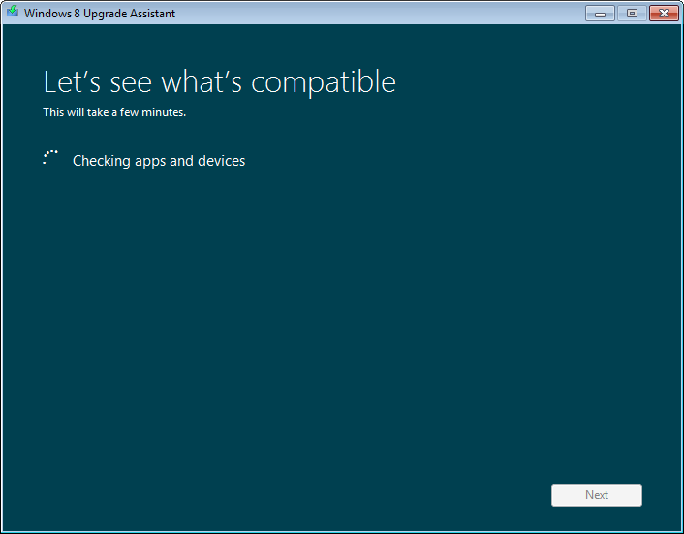

Figure : Upgrade Assistant

The results of the compatibility check are shown in summary form as in the example below.

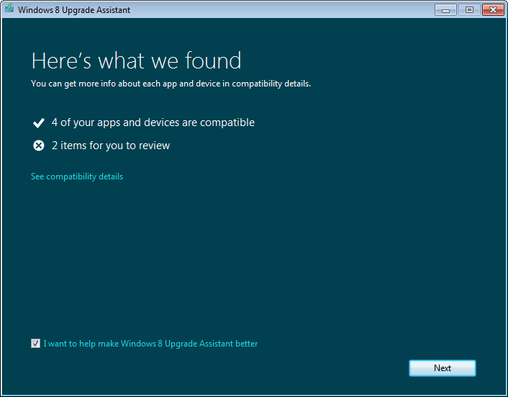

Figure : Upgrade Assistant compatibility results

Apps and devices are listed as either “will work,” “may work,” or “will not work.”

You can click the **See the compatibility report** link to show more details, as shown in the image below. Links are provided for more information, from Windows Online as well as third-party sites where appropriate.

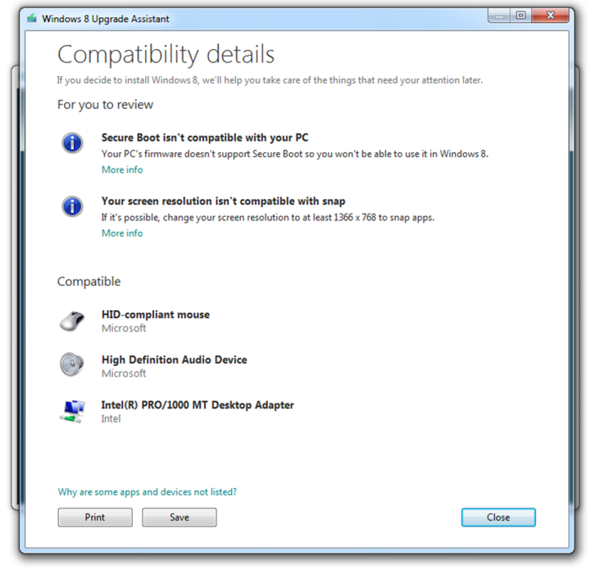

Figure : Upgrade Assistant compatibility details

**Note:** These compatibility results are also saved as DetailedReport.html and saved to the logging location for Web Setup: %LocalAppData%\Microsoft\WebSetup\Panther. After setup is complete, this file can be found in the \Windows\Panther folder.

### Web Setup: Purchase

The next step for the Upgrade Assistant to ask what elements of the current configuration you would like to keep. You will see only the migration options available to you, based on your current Windows version. This selection is needed prior to purchase in order to determine which Windows 8 options to list in the next step.



Figure : Web Setup ― choose what to keep

If you are running Windows 7 Professional or Ultimate edition, and the **Windows settings, personal files, and apps** option was selected above, then there is only one choice of Windows 8 editions provided. The only full migration path from these Windows 7 editions is to Windows 8 Pro. This is shown in a pre-release mock-up below.

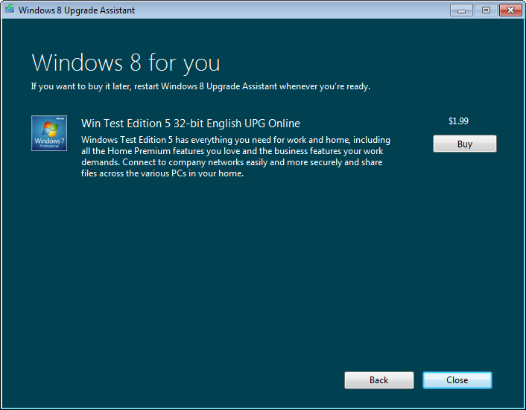

Figure : Web Setup ― purchase options

If you are running a lower edition of Windows 7, or if you selected something other than a full migration in the previous step, you would see both Windows 8 and Windows 8 Pro offered, as shown below.

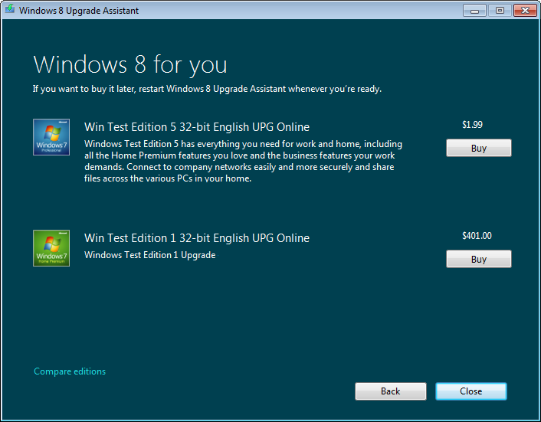

Figure : Web Setup ― additional purchase options

Clicking the **Buy** button in the above step will bring you to the next step, where you provide billing information.

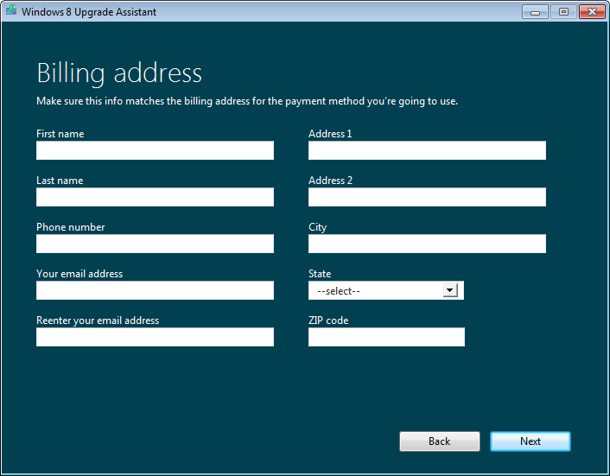

Figure : Web Setup ― billing information

The next step provides a choice of payment options. In the example below, the choices are **Credit card** or **PayPal**. These may differ in the final release of Windows 8, and they may differ by locale.

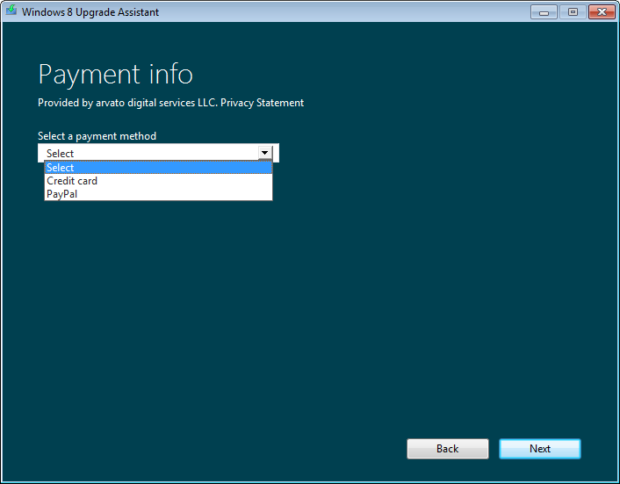

Figure : Web Setup ― payment info

If you select **Credit card** above, you will see payment entry information, as shown below.

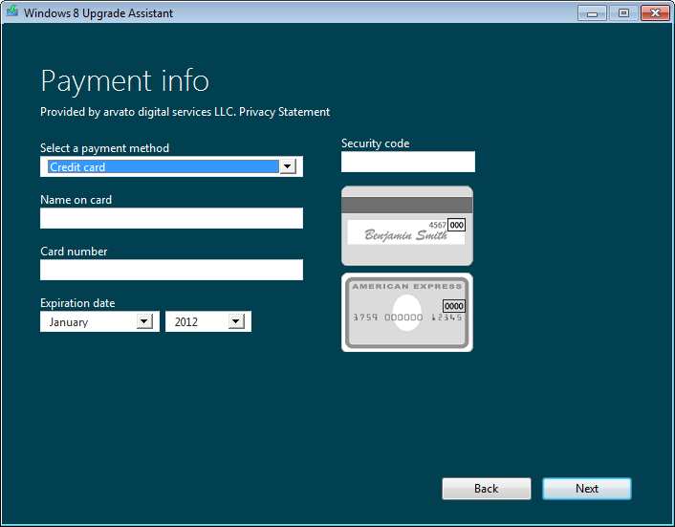

Figure : Web Setup ― payment information

The **PayPal** option will take you through a typical PayPal payment process.

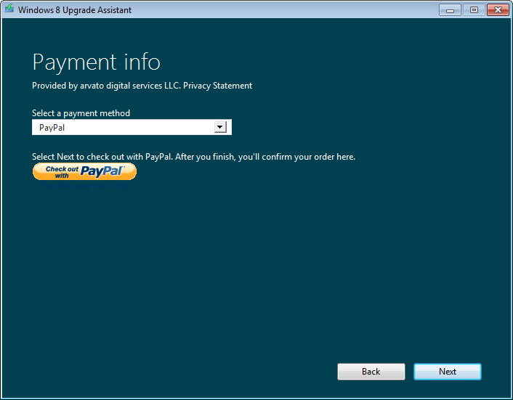

Figure : Web Setup ― PayPal

Once your payment has been entered and you click **Next**, the order confirmation is shown. An example of this is shown below. If you are purchasing Windows 8 using the Windows 8 Upgrade Offer, the **Promo code** field is where you enter the code for this discounted offer. Be sure to click **Apply** and confirm that you see the promotional pricing before clicking **Next**.

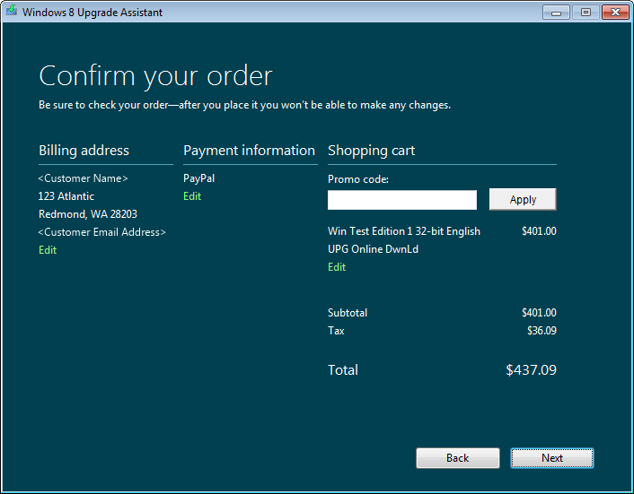

Figure : Web Setup ― order confirmation

Once you click **Next** in the payment confirmation, the Upgrade Assistant completes the order with the ecommerce infrastructure and retrieves a product key.

### Web Setup: Obtain Product Key

The retrieval of the product key is done via interaction with the online service for Web Setup. The key is displayed so that you can make a note of it, but it is automatically passed to install.exe if you complete the installation immediately after the download is compete.

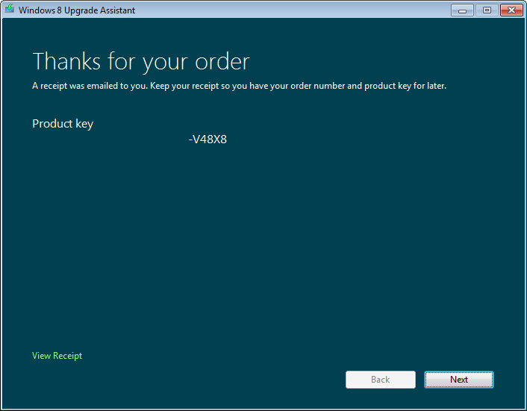

Figure : Web Setup ― order complete with product key

Clicking **Next** above starts the download.

Clicking the **View Receipt** link displays the purchase receipt including the product key, as shown in the example below. This gives you a summary of the purchase. This purchase information is also sent to the email address provided during the purchase.

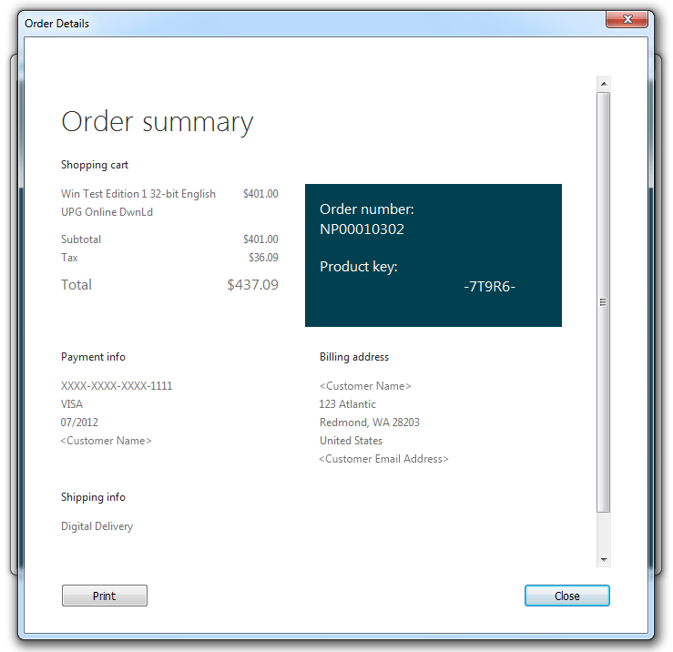

Figure : Web Setup ― order summary

### Web Setup: Download

At this point, the Windows 8 installation source is downloaded via the Background Intelligent Transfer Service (BITS). This step shows an estimate of time remaining, as well as a pause button so that the user can control when Web Setup uses the Internet connection.

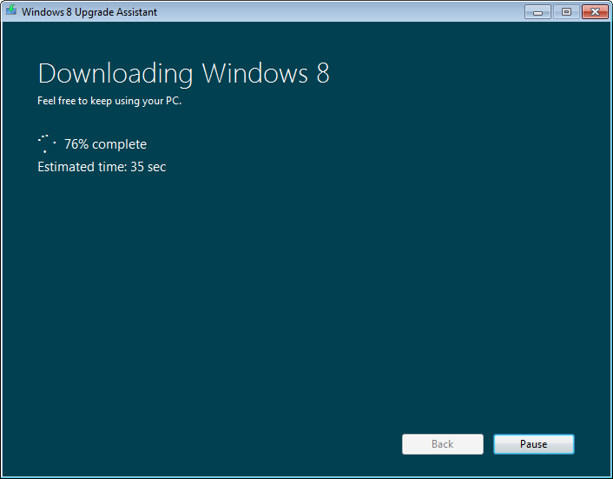

Figure : Web Setup ― download

**Note:** If the download process is interrupted for any reason, you can use the Download Windows shortcut on the desktop to resume where it left off.

The download is followed by steps that verify download integrity and prepare the downloaded installation source for use. You will see these reported as “Checking the download” and “Getting files ready.” If there was an issue with the downloaded file, you may see additional steps where the Upgrade Assistant performs self-correction to obtain a good file. At this stage, there is also a check for dynamic updates. If updates are found, the installation source is updated with these latest improvements.

Once these steps are complete, the installation source files will be in the C:\ESD\Windows folder, which is the location used to launch install.exe.

### Web Setup: Start Setup or Create Install Media

When the installation source is prepared, you have three choices for proceeding, depending on whether you want to install over the current Windows installation, create installation media, or install later.

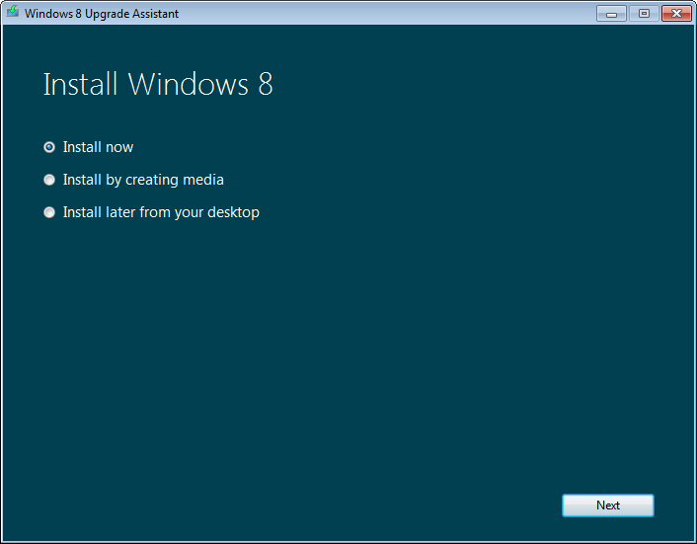

Figure : Web Setup ― install option

The next step depends on the customer’s choice of the following options:

* **Install now:** This choice starts Install.exe immediately. See the topic “Down-Level Phase” later in this module to continue the flow at this point.
* **Install by creating media:** To install on another partition, the PC must boot from the Windows 8 installation media. This option creates an ISO file or bootable USB flash drive, which can be used to install on this, or another PC of the same architecture. See the topic “Creating installation media” later in this module for more information.
* **Install later from your desktop:** This option places an Install Windows shortcut on the desktop. That shortcut can be used to start install.exe later.

**Note:** You can return to this step after exiting Web Setup by running the Install Windows desktop shortcut.

### Down-Level Phase

If you continue on with the installation by selecting **Install now** above, Web Setup starts down-level setup by launching install.exe from the downloaded installation source. This is located in C:\ESD\Windows, by default.

You will go directly into down-level setup if you start setup from a Windows 8 DVD within a running Windows operating system. This section describes the steps performed during the down-level phase. For Windows 8, the process is the same whether you are starting setup from Windows XP, Windows Vista, Windows 7, or Windows 8.

**Note:** Steps 1-4 below do not appear if Web Setup was used to begin the installation.

1. Setup.exe is started from the installation media, which in turn starts Install.exe.
2. **Accept** is selected on the User Account control prompt, if it appears.
3. Dynamic Update is offered, along with the option to opt out of the Customer Experience Improvement Program (CEIP) for Windows 8 setup, as shown in the image below.

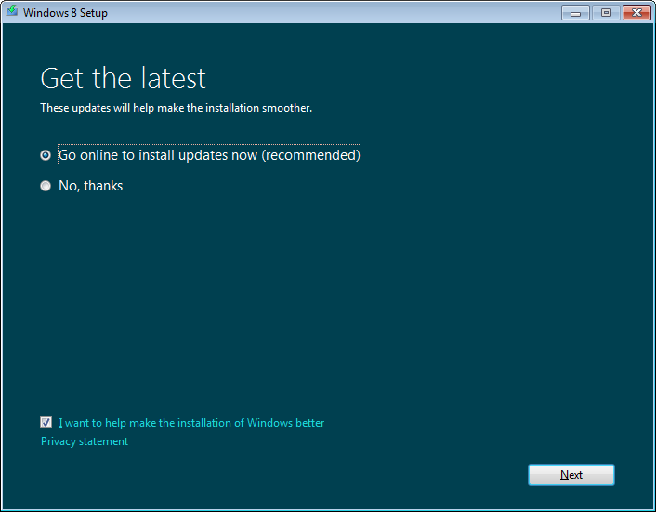

Figure : Down-level dynamic update

1. After you click **Next** above, Windows Setup initiates the dynamic update process and checks for and downloads any updates for setup.

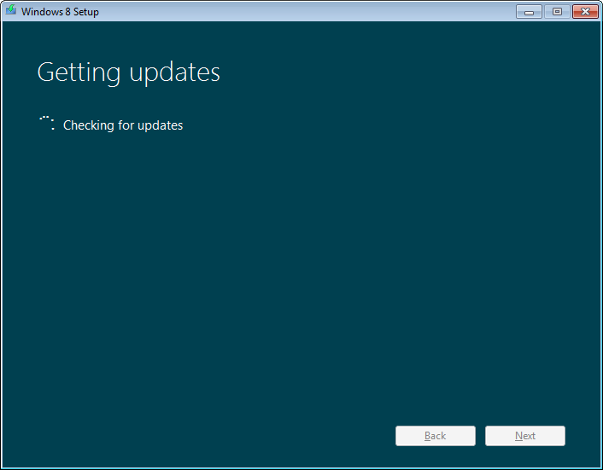

Figure : Down-level dynamic update

1. Next, Setup verifies that the PC meets the system requirements. This is a check for processor requirements, system memory, and other attributes.
2. Setup then verifies the product key, if the key is included as part of the installation source. This is the case for Web Setup. If the product key has not been provided, such as for an installation started directly from a DVD, you will see the Product Key prompt.

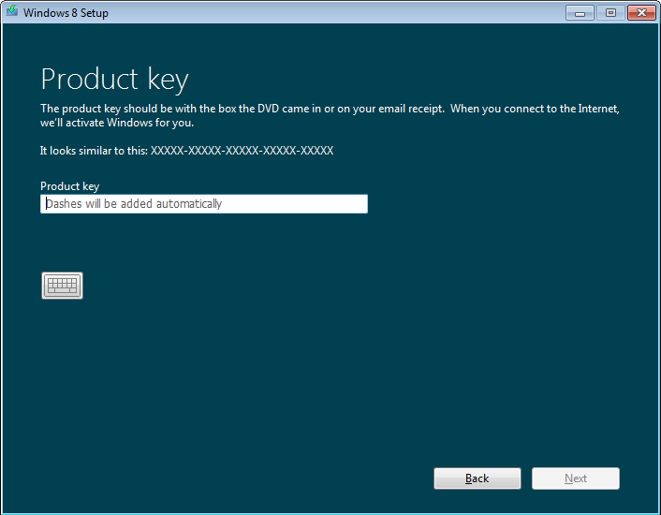

Figure : Down-level product key

1. Next, you are prompted to accept the license terms. The **Accept** button is disabled until you check the box to indicate acceptance of the terms.

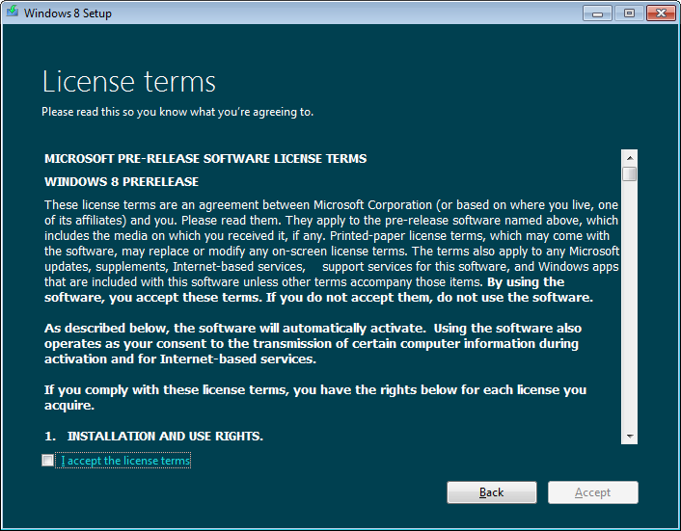

Figure : Down-level license terms

1. Next, you are asked what you would like to migrate to the new installation. This option is only shown if you did not indicate your preference earlier. Similar to the product key prompt, you can expect to see this when starting setup from a DVD, or when starting setup later from a downloaded source.

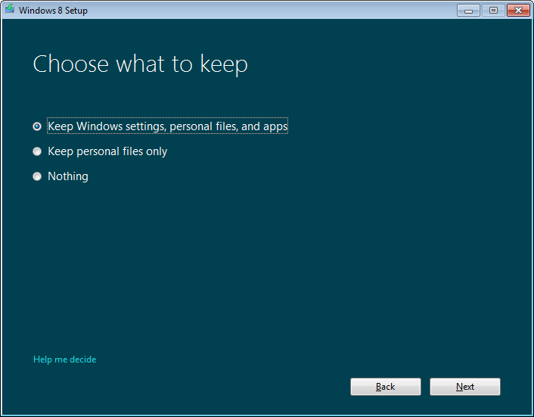

Figure : Down-level choose what to keep

1. Next, setup performs a compatibility check to ensure that there are no problems or conflicts that would prevent you from being able to install Windows 8.

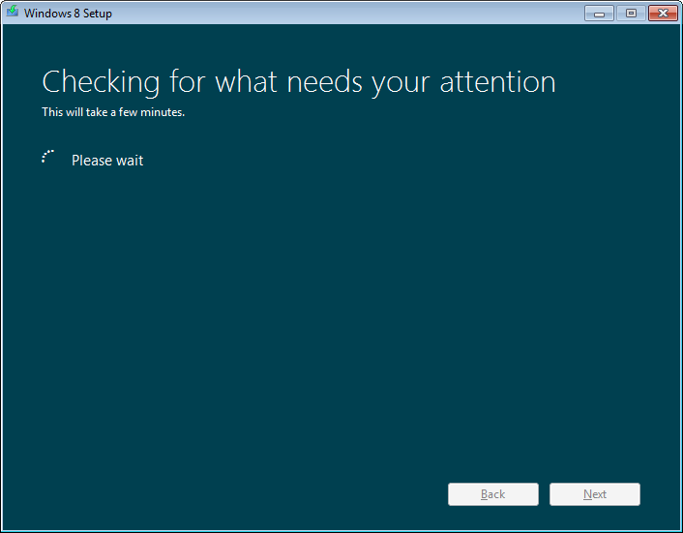

Figure : Down-level compatibility check

1. (Optional) If Setup needs to make any changes to your PC, or if there are any issues that need to be addressed before Setup can proceed, you will be told at this point, as shown in the image below. If any of the changes that are needed do not require a reboot, you can click the Refresh List button and that item should be removed from the list. If there were only items that did not require a reboot in that list previously, and the list is now empty, you will be able to proceed without needing to restart Setup.

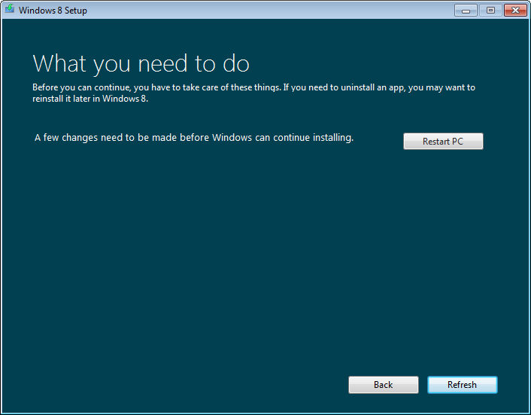

Figure : Down-level changes required

This step in Setup could require changes such as restarting to complete pending actions, suspend BitLocker® protection, or other actions that could create an issue during installation.

Note that for actions that do not require a restart, you can use the button for the change, and return to this step to continue without restarting Setup. When no actions remain, the **Refresh** button will change to **Install**.

1. (Optional) If a restart was required, after the restart, Setup will automatically pick up where you left off.

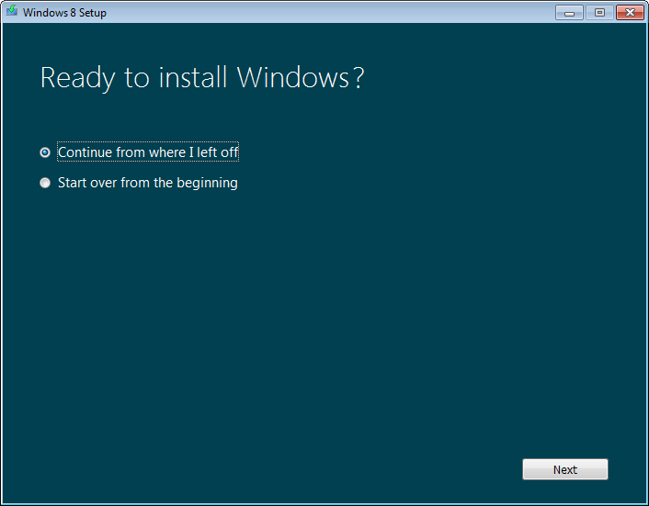

Figure : Down-level changes required, continue

1. At this step, Setup is confirming the next steps that it will take based on the choices you have made. Clicking the **Change selection** link will take you back to the “What would you like to keep?” step.

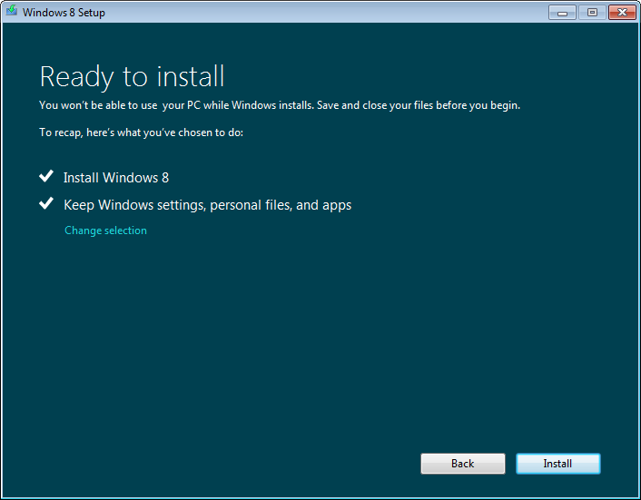

Figure : Down-level ready to install

1. After clicking the **Install** button, the installation process switches from a normal desktop Window to full screen and begins installing Windows on the PC.

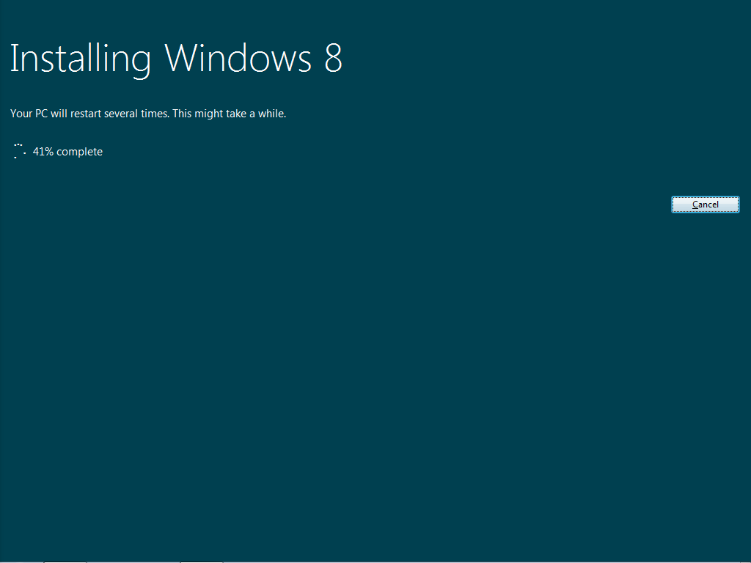

Figure : Down-level installing

### WinPE and First Boot

Next, the PC will reboot into the WinPE phase and then into the first boot phase. These two phases are very similar to Windows 7 in underlying activity, but visually, they are masked by a full-screen interface with minimal detail showing what is happening. An example of this is shown below.

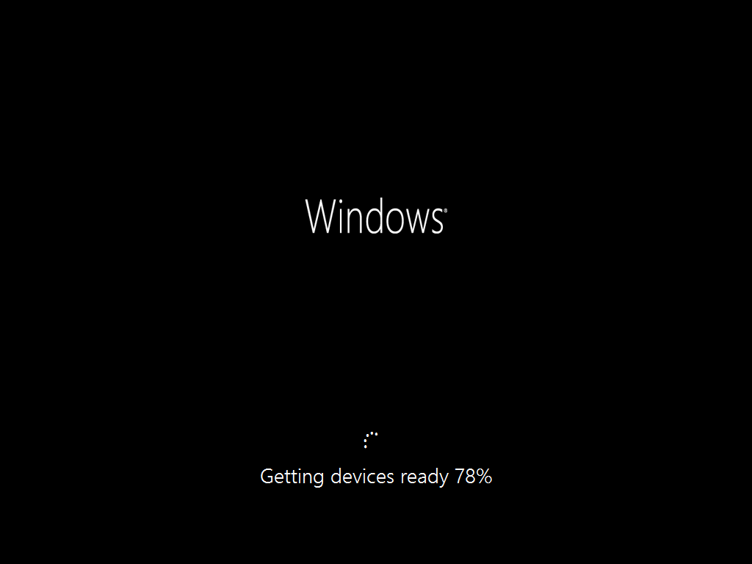

Figure : WinPE mode and first boot

Generally speaking, you will see a progression of screens and around three restarts like this:

* Restart
* Preparing x%
* Restart
* Please Wait
* Preparing
* Getting Devices Ready x%
* Getting System Ready
* Preparing x%
* Restart
* Moving your settings x%: This only appears if installing with data migration enabled.

When this last step is complete, the Windows Welcome phase begins.

**Note:** Some of the steps above may differ, depending on the configuration of the PC and of Setup. For example, there may be more restarts or fewer, as needed to install drivers.

### Windows Welcome

Windows Welcome is a wizard that guides you through the initial setup and personalization of Windows on your PC. This is also sometimes referred to as the OOBE (Out of Box Experience) or the First Run Experience in other Microsoft products. When interacting with customers, please use the term Windows Welcome.

Windows Welcome is the first part of Setup that most users will see when they are starting a new PC that was purchased with Windows 8 preinstalled.

This section outlines the steps that are shown during this process.

1. Next, you are prompted to choose a background color. You are also asked to enter a computer name if this was a clean install instead of an upgrade.

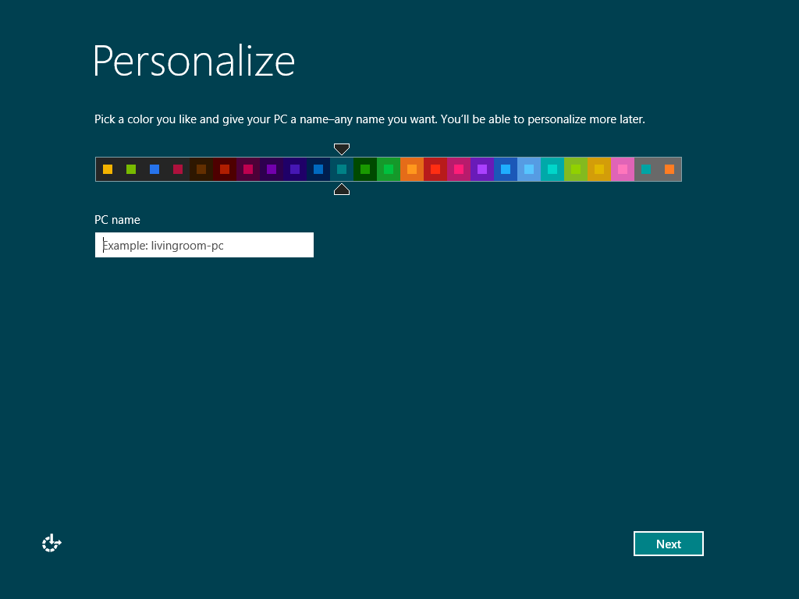

Figure : Windows Welcome Personalize

1. If you have a wireless adapter for which Windows 8 includes drivers in the box, you will be prompted to select your wireless network from the list of available networks. Each network shows signal strength and a warning shield is shown for unencrypted networks.

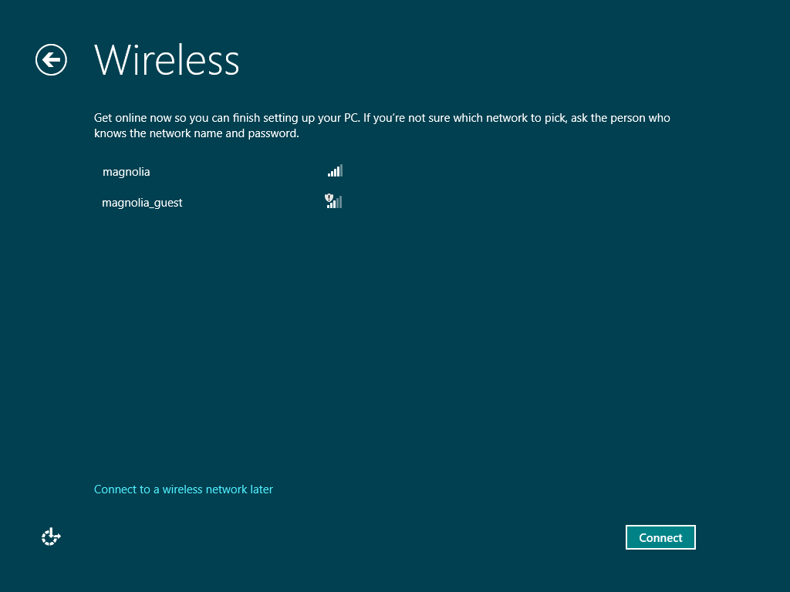

Figure : Windows Welcome Wireless

**Note:** If you have configured your wireless network to prevent SSID broadcast, it will not appear in this list. Use the **Connect to a wireless network later** option, and then configure the connection in Windows.

1. When you select an available network, you can choose whether to connect automatically in the future. This option is selected by default.

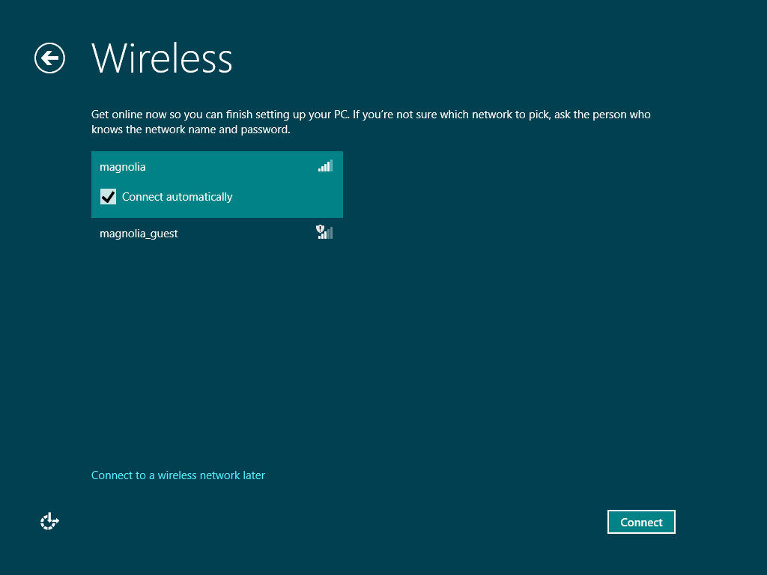

Figure : Windows Welcome Wireless―connect automatically

1. If the network you selected uses encryption, the next step is to enter the password. Click **Connect** to make the connection.

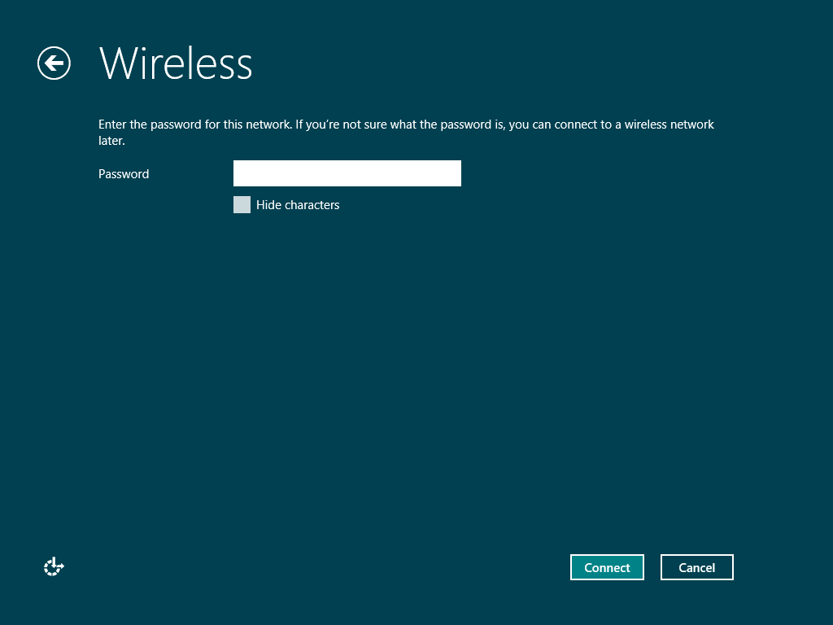

Figure : Windows Welcome Wireless―enter key

1. After connecting to the network, you will need to configure other initial settings related to the different services and features provided by Windows and Windows Live. You can choose the **Use express settings** option to accept the defaults and skip to the “Sign on” step of the wizard, or you can choose the **Customize** button to verify these settings individually.

For the purposes of this training, we will walk through the Customize path of the wizard.

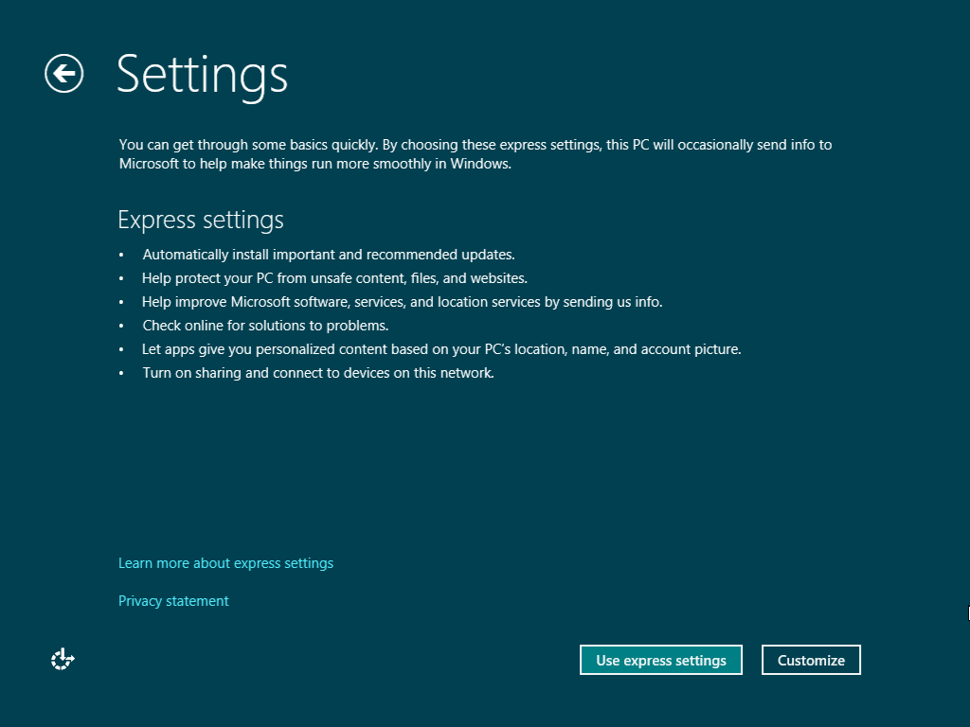

Figure : Windows Welcome settings

1. If you chose the **Customize** option, the first thing you will be prompted for is whether or not you would like to share resources on the network. This option will set the category of the network as shown in the Network and Sharing Center.

The first option will set the network to be a private network and the second option will set the network to be a public network.

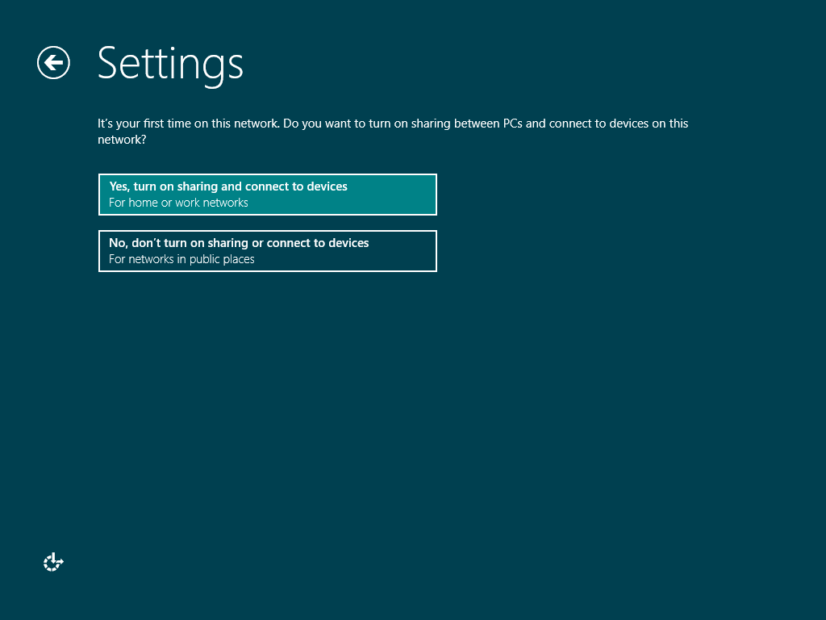

Figure : Windows Welcome settings―sharing

1. The next page will show various options related to automatically installing Windows and driver updates, as well as options related to the SmartScreen® filter.

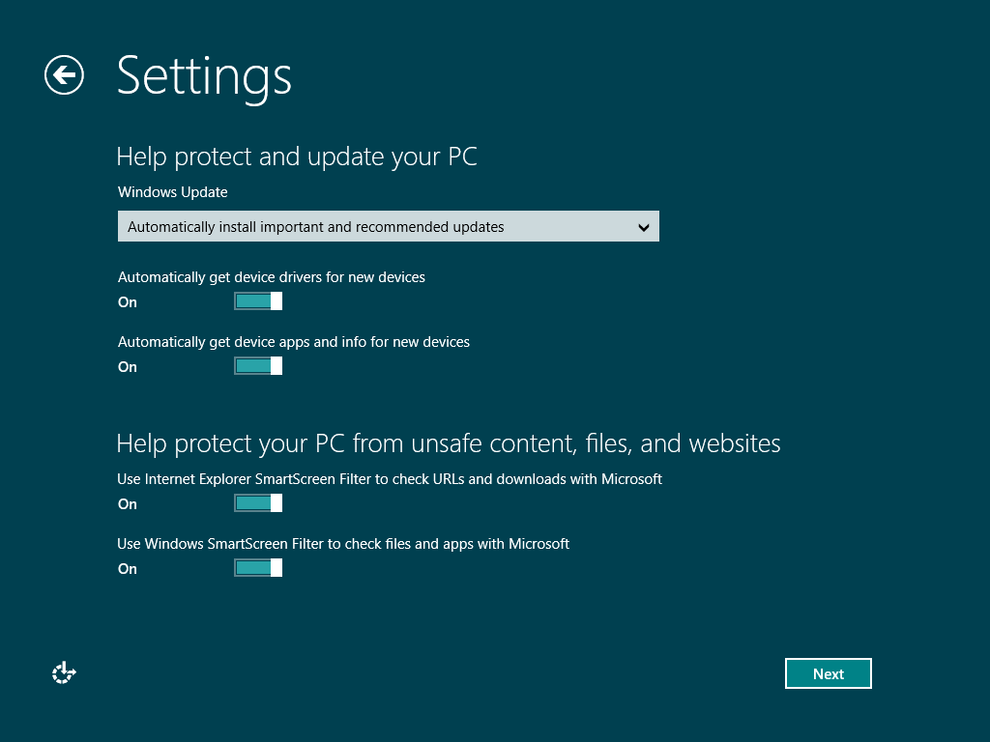

Figure : Windows Welcome settings―protect and update

1. The next settings page shows options related to providing usage and other related information to Microsoft for product improvement.

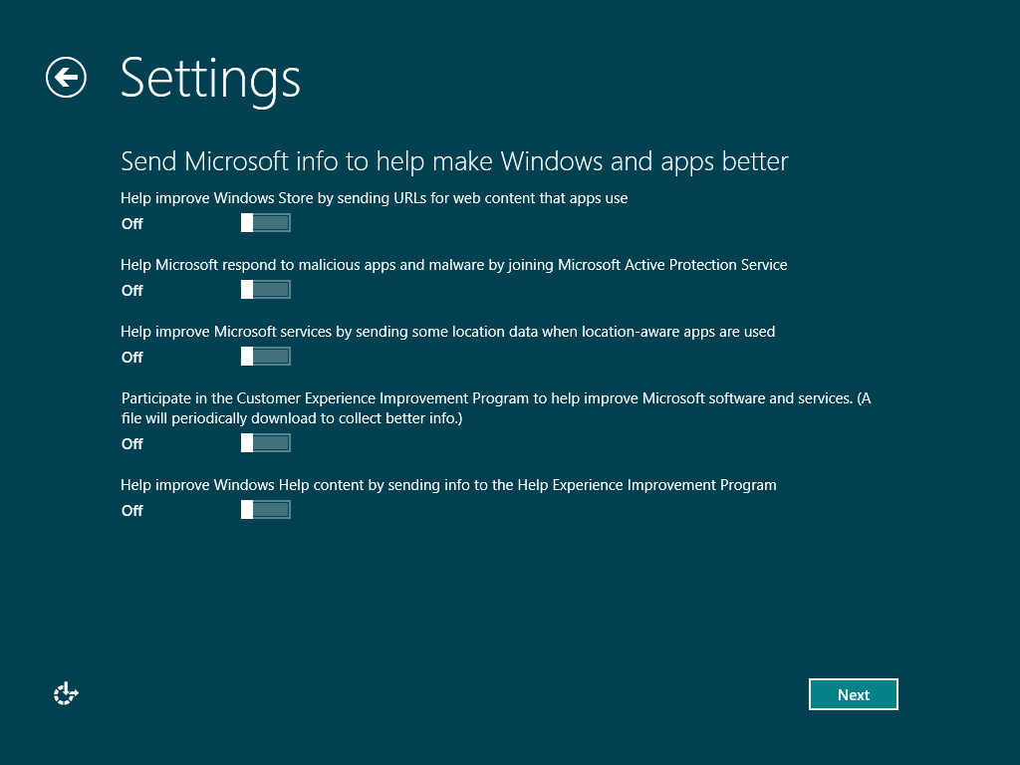

Figure : Windows Welcome settings―make Windows better

1. This page shows settings related to using Microsoft services to fix issues and lets you configure what information that you want to share with your apps.

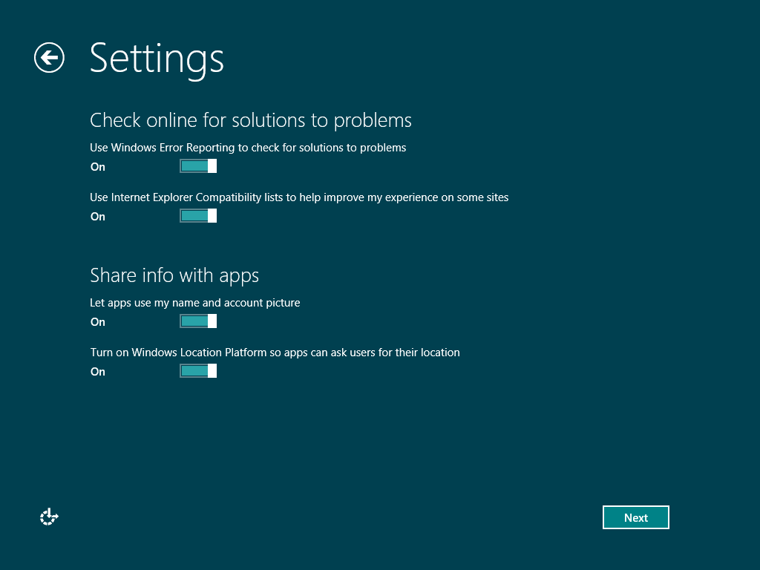

Figure : Windows Welcome settings―check for solutions

1. After the Settings page (or pages if you chose the **Customize** option), you will be prompted to provide an email address for signing on to Windows. The default option for creating an account in Windows 8 is to use a connected account, which uses your Microsoft account and password to sign on to Windows. The email address provided here should be a Microsoft account, although if you do not have a Microsoft account, you will be able to create one from this interface. If you do not want to create a connected account, you can create a local account by clicking the **Don’t want to sign in with a Microsoft Account?** link. To see the steps for creating a local account, see step 13 below.

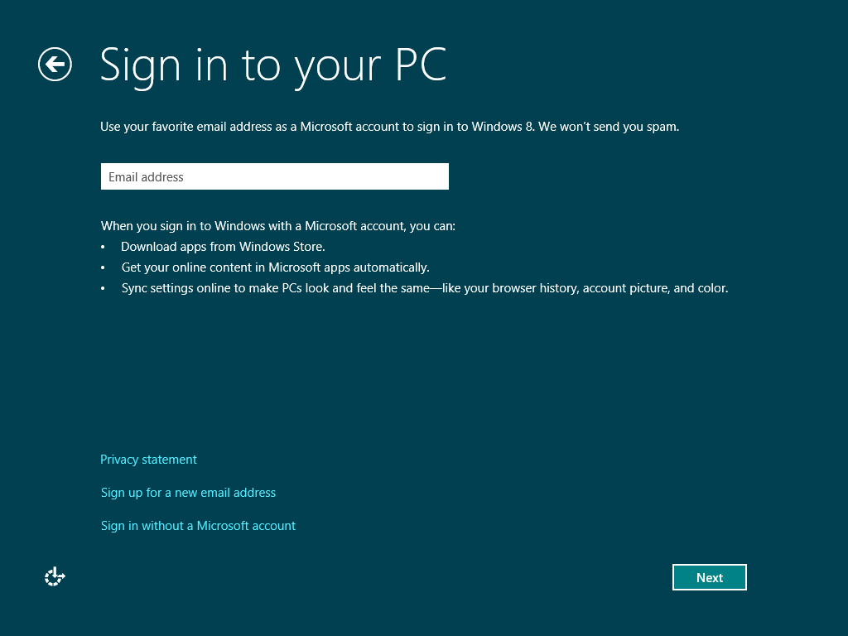

Figure : Windows Welcome―sign in

**Important:** If you have Microsoft account, or Live ID that you use with Xbox or Windows Phone, using that same account with Windows 8 will give you a more seamless experience.

**Note:** More information about connected accounts is provided in the Connected Accounts module later in the training.

1. After entering your Microsoft Account and clicking **Next**, you will be prompted to enter the password for your Microsoft Account. The email address field will be automatically populated with the Microsoft Account that you entered on the previous step. When you click **Next** you may be prompted to enter verification information. This is used to help protect your account. To see this, skip to step 13 below.

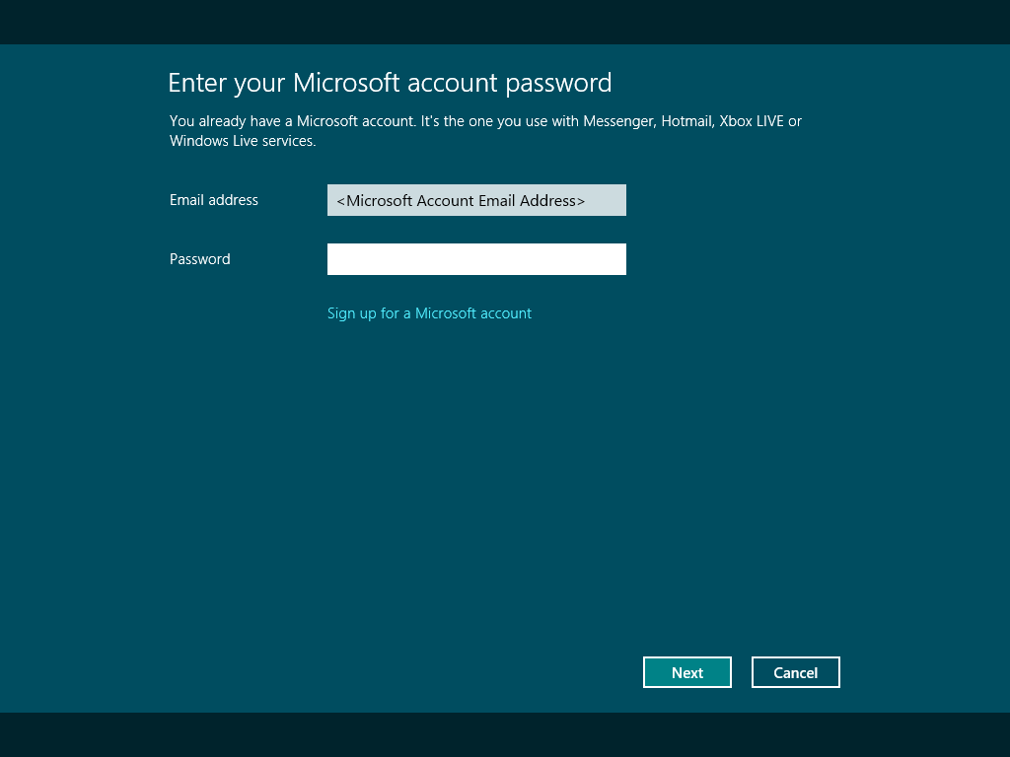

Figure : Windows Welcome―enter password

1. Another option is to create a new email address from the Sign-in step above by entering a new @live.com or @hotmail.com email address. In this case, you will see a sign-up step, as shown below.

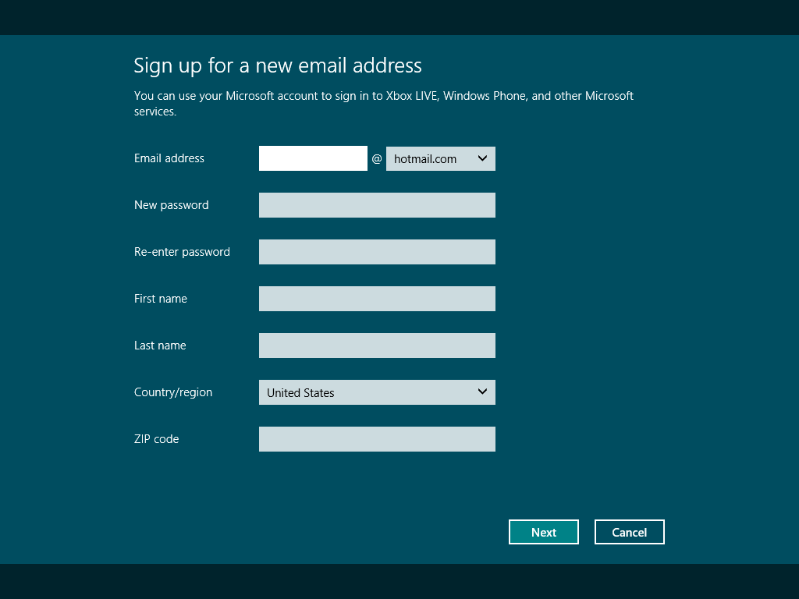

Figure : Windows Welcome―sign up

1. The next step prompts for security verification information for the Microsoft Account. This information can be used to verify ownership of a Microsoft Account for account recovery or other support scenarios.

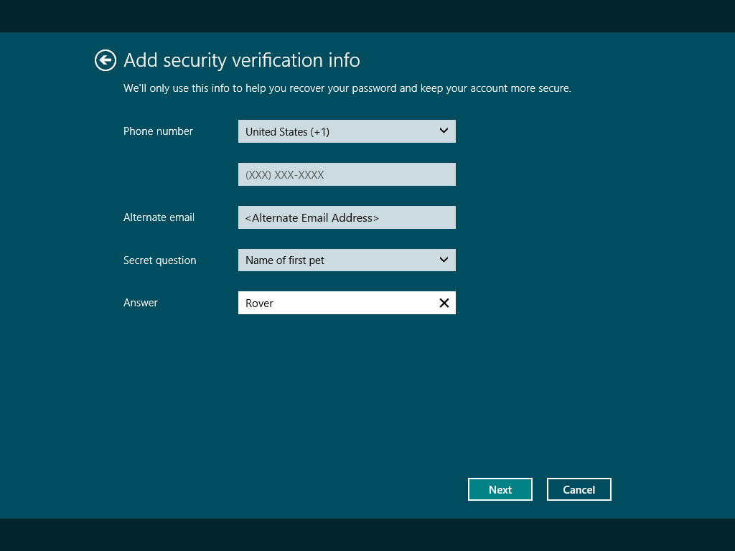

Figure : Windows Welcome―security verification

1. If you created a new email address above, you will next be prompted for birthday information, gender, and an option to receive promotional offers. This step also includes a reCAPTCHA prompt. This is designed to help prevent automated email account creation. If you are unable to read the characters you can click **New** to see a new example. For more information see the reCAPTCHA site here <http://www.google.com/recaptcha>. This is the last step of the wizard if you have followed this path.

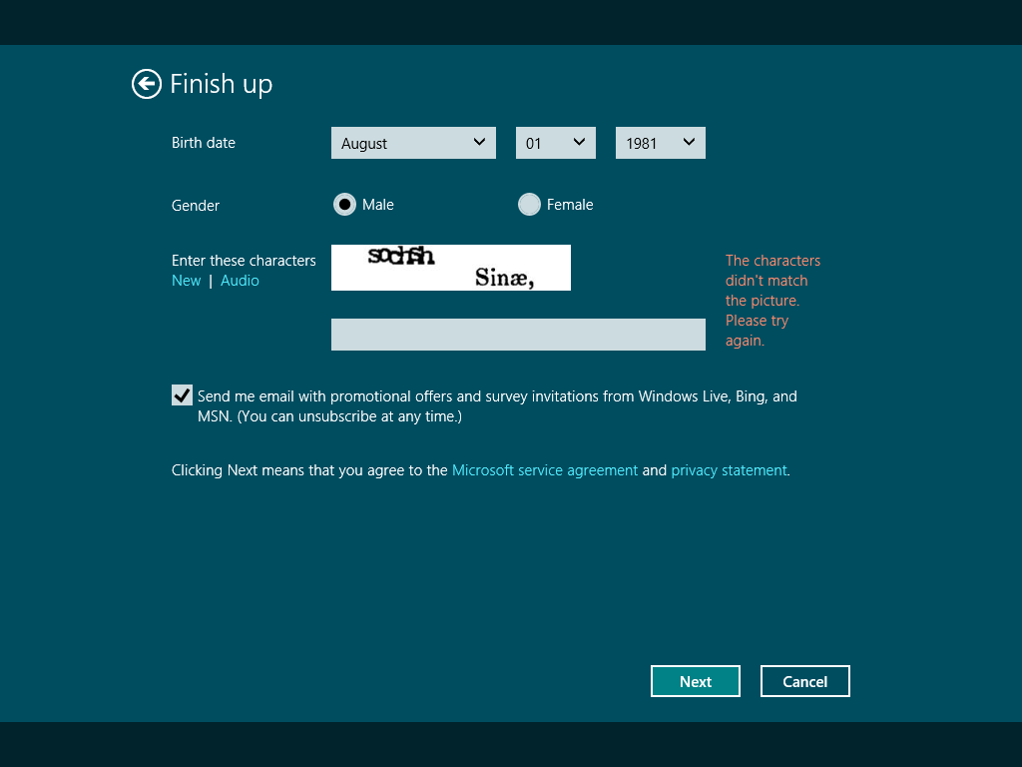

Figure : Windows Welcome―sign up finish

1. If you chose the **Don’t want to sign in with a Microsoft Account?** option at step 10 above, you will be presented with the step shown below. This compares the two different types of account that can be created for Windows 8. To create a local account, click the appropriate button.

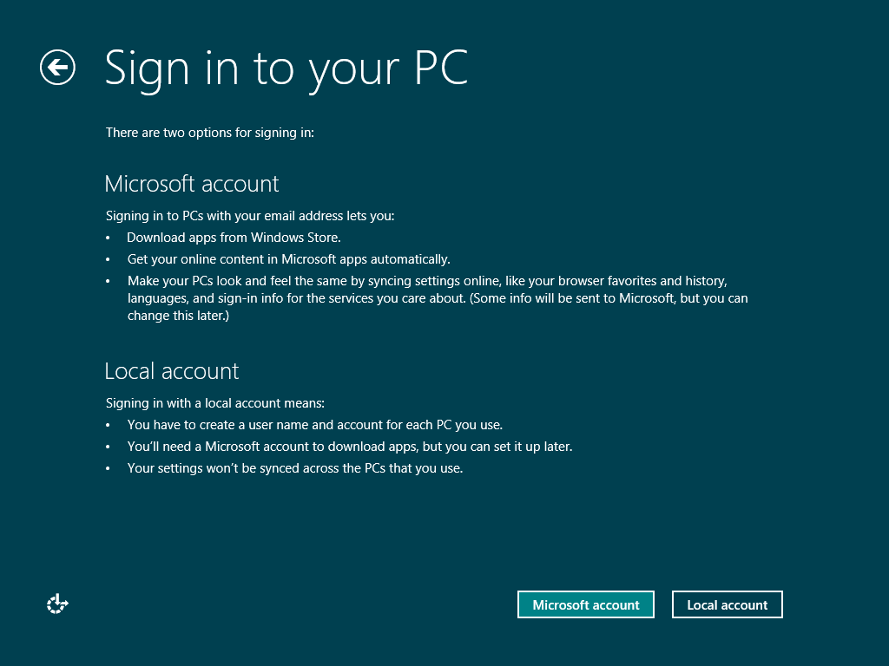

Figure : Windows Welcome―account comparison

1. On the local account creation screen, you will see more traditional options for creating a user account, such as defining the user name, typing the password twice, and entering a password hint. Text must be entered into the password hint field to continue. This is the last step of the wizard, so after clicking the **Next** button, you will be signed into Windows 8 using the local account you just created.

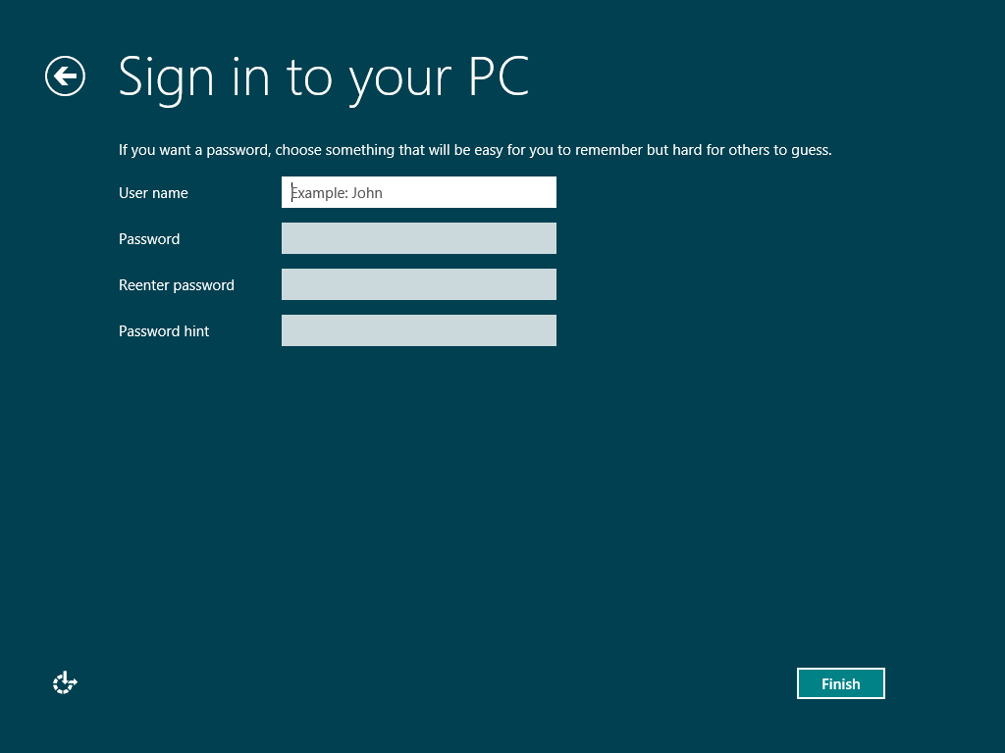

Figure : Windows Welcome―local account

At this point setup is complete, you are logged in to the PC and the new Start screen is loaded.

## Setup Flow: Boot From Media

The flow of installation is somewhat different when you start by booting from Windows 8 media. This type of setup is the most common for new PCs with a blank hard disk, or when you need to install to a different partition, or change Windows architectures.

The flow of setup actions proceeds generally like Windows 7, so it is not examined in depth below. What follows is a summary of actions.

1. You begin this type of installation by inserting a DVD or USB flash drive with the Windows installation files and booting the computer from that disk. This may require that you modify the boot order in the BIOS or press a specific function key (F12, F10, etc.) to display a boot menu from which you could choose the DVD or USB flash drive that you are attempting to boot from.
2. WinPE Mode: This is the first setup phase when you boot from the media. It starts with a language and keyboard format selection step. This is hosted in an environment similar to Windows Recovery Environment (WinRE). In the next step, as in Windows 7, you can choose to install or repair your PC.

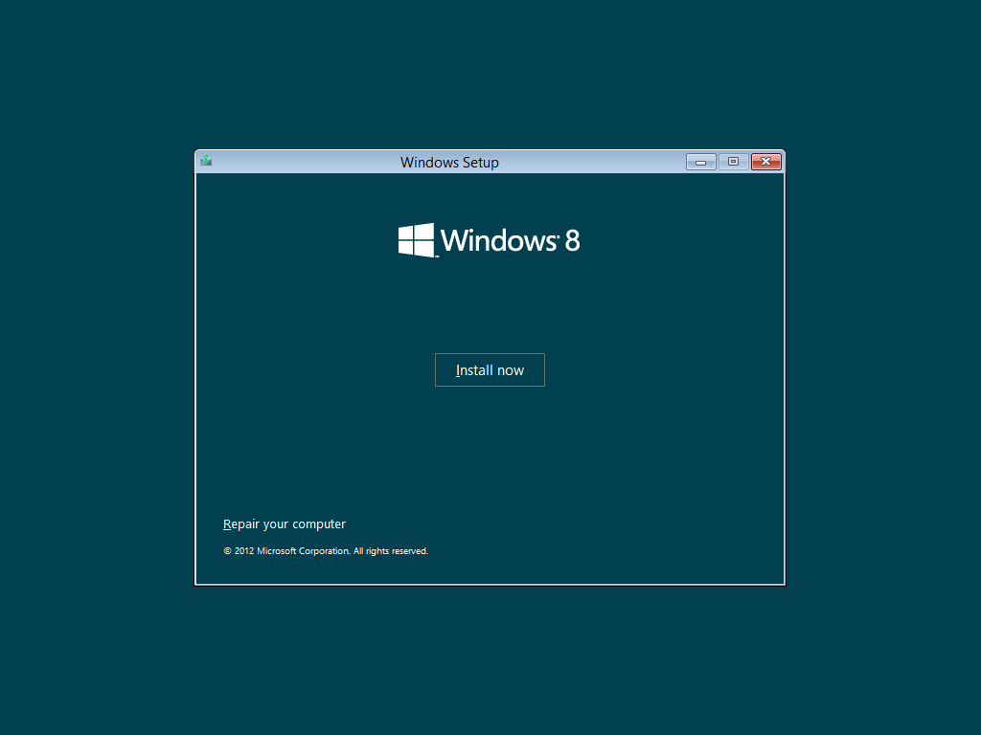

Figure : Media boot install now or repair your computer

1. After you click **Install now**, you must enter a product key. This is not optional in Windows 8 setup.

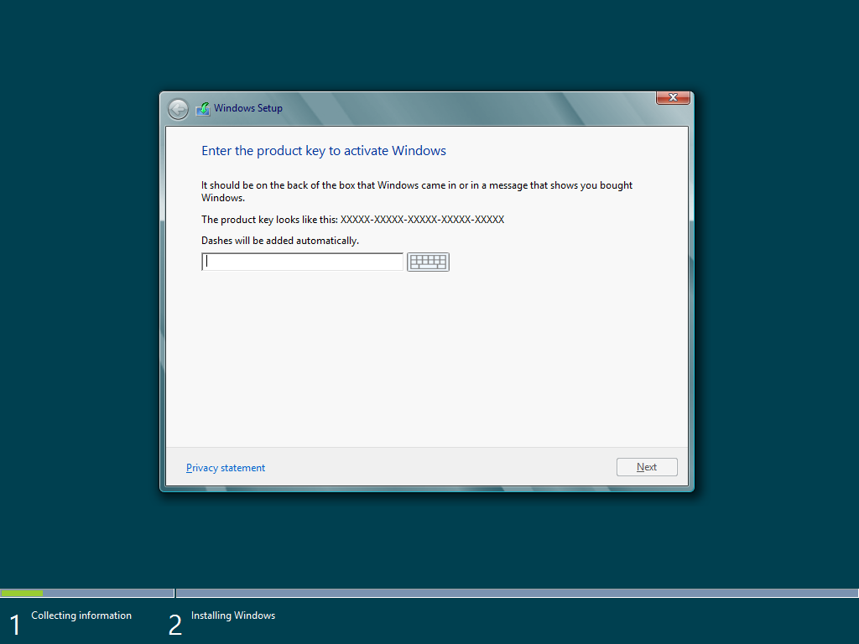

Figure : Media boot product key

**Note:** Because product key entry is not optional in Windows 8, and the key you receive with a retail purchase of Windows 8 is a compliance-checking key, your previous Windows version must be installed on the PC before you can complete the installation.

1. And then next, you can select what type of installation you want. Notice that this is showing the same type of options as were used in Windows 7. The Setup.exe engine still exists on the media, and it is used in this scenario. The **Upgrade** option in this scenario simply leads to a message explaining that you must start setup within Windows in order to upgrade. So the **Custom** option is what you need to select to continue installing in this scenario.

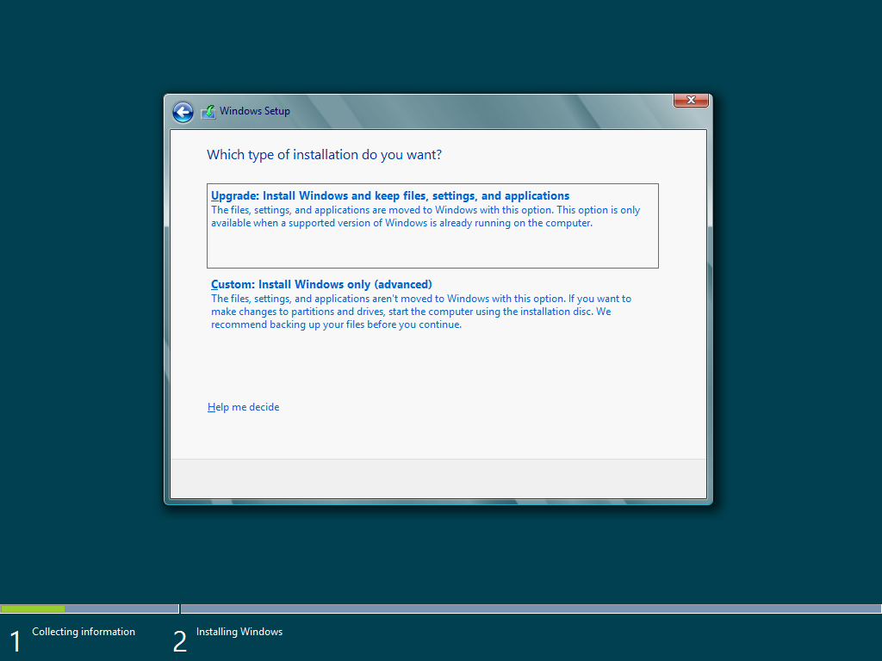

Figure : Media boot WinPE mode

1. Installation then proceeds the same as it did in Windows 7 until the restart. Progress is shown in the interface until the first restart.
2. From that point, you will see the same general sequence of events as were listed for the install from within Windows above:
   1. Restart
   2. Preparing x%
   3. Restart
   4. Please Wait
   5. Preparing
   6. Getting Devices Ready x%
   7. Getting System Ready
   8. Preparing x%
   9. Restart
3. Once you reach Windows Welcome, the steps are consistent with the Windows Welcome experience shown earlier.

This takes you to the end of installing by booting from the media.

## Dual Boot Configuration

Configuring a dual boot installation can be done by booting from the media and choosing a custom installation. As with earlier Windows versions, if you install to a different partition or drive from your current Windows installation, you will end up in a dual-boot configuration.

This is not a path provided in the new consumer-friendly Install.exe interface when running Windows 8 Setup within an existing Windows installation. If you want to set up a dual boot configuration of Windows 8 with another Windows version, use the steps below:

1. Install the earlier Windows version first.
2. Boot from the Windows 8 installation media: You can do this via Web Setup by creating bootable USB or DVD media, or by using a purchased DVD to perform the installation.
3. Install Windows 8 to a partition that does not contain the current Windows installation.

**Tip:** You can use Shift+F10 while in Setup if you need to verify which partitions contain another Windows installation. Check each drive letter with the **dir** command to see which drive letters have a Windows directory.

Once Windows 8 has been installed, you will see a graphical boot menu for selecting the operating system during startup. An example of this is shown below.

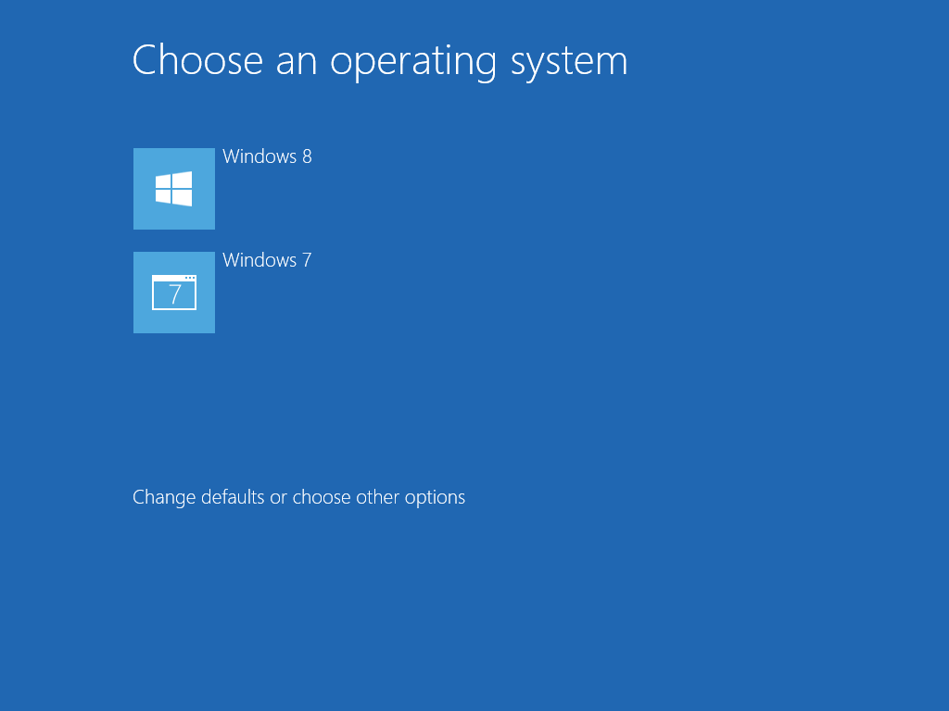

Figure : Boot menu

Unlike the boot menu in Windows 7, this is a graphical interface. You can use a mouse or touch input to select an operating system or enter the options interface, which is shown below.

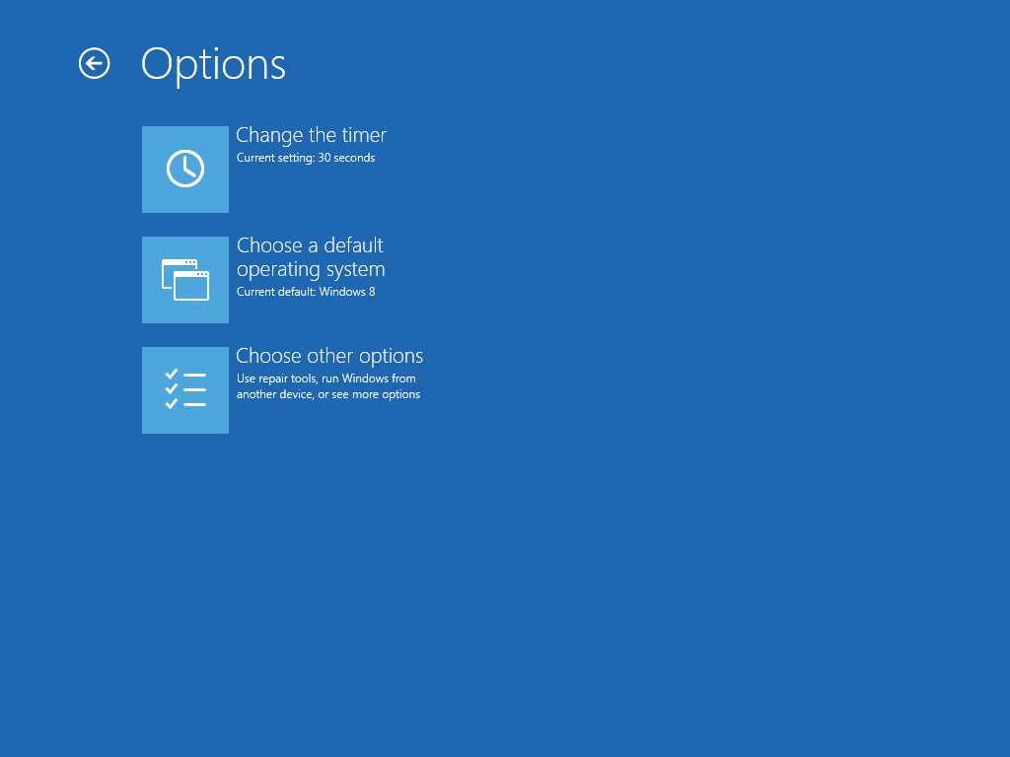

Figure : Boot menu options

Timer settings are available, as are default operating system selection, and other options like repairing Windows using the Refresh or Reset features.

## Web Setup Details

When the Upgrade Assistant is downloaded and run, it expands the Web Setup components into the folder %LocalAppData%\Microsoft\WebSetup\Sources. A shortcut named “Install Windows” is also placed on the desktop, pointing to WebSetup.exe in this location. This shortcut can be used to re-launch setup later.

If you complete the Windows 8 download process, the shortcut on the desktop will point to “WebSetup.exe /late elevated”. This causes Web Setup to start directly to the “Install options” step, shown at the end of the “Web Setup phase” topic earlier in this module. At this step, the user is given the choice to install now or “Install to another partition” in order to create bootable installation media.

### Logging in Web Setup

The Web Setup log files are saved in the user profile of the user who ran setup. The path is %LocalAppData%\Microsoft\WebSetup\Panther.

If you choose to start an installation directly from Web Setup, the log files in this location will be used to start the Install.exe logging. This ensures that you have a Setupact.log that shows the full end-to-end installation, from the start of Web Setup through the end of Windows Welcome.

### Download Process

Web Setup uses BITS to download the Windows 8 installation source from regionally distributed servers. This will help to make the download process as quick as possible. You can use bitsadmin.exe or the PowerShell BITS cmdlets to view the status of this job, as well as to delete the job in the event of a significant problem. The BITSAdmin command to view the download job details is:

bitsadmin /info "Windows Dlp Manager" /verbose

Be aware that the job name in quotes is case-sensitive.

Example output from this command is shown below:

GUID: {08FB0806-65B6-46D5-852F-BAAB3E59D6CC} DISPLAY: 'Windows Dlp Manager'

TYPE: DOWNLOAD STATE: TRANSFERRING OWNER: Username-PC\Username

PRIORITY: FOREGROUND FILES: 0 / 1 **BYTES: 247647627 / 1725100734**

CREATION TIME: 6/14/2012 9:11:31 PM MODIFICATION TIME: 6/14/2012 9:43:13 PM

COMPLETION TIME: UNKNOWN ACL FLAGS:

NOTIFY INTERFACE: REGISTERED NOTIFICATION FLAGS: 11

RETRY DELAY: 60 NO PROGRESS TIMEOUT: 1209600 **ERROR COUNT: 0**

PROXY USAGE: PRECONFIG PROXY LIST: NULL PROXY BYPASS LIST: NULL

DESCRIPTION:

JOB FILES:

247647627 / 1725100734 WORKING http://pr.win.esd.microsoft.com/WRPDL/F736C5B1D8A9D4F8CD29D6C8FDFD92DFBF956B5DA/Windows8-ReleasePreviewElectronic-32bit-English-X1826135.esd?t=28745790-d73f-4550-9b8d-304966b6079e -> C:\Users\Username\AppData\Local\Microsoft\WebSetup\Download\WinPayload.esd

NOTIFICATION COMMAND LINE: none

owner MIC integrity level: HIGH

owner elevated ? true

Peercaching flags

Enable download from peers :false

Enable serving to peers :false

CUSTOM HEADERS: NULL

The “BYTES” information in bold in the above output is useful as it shows if the download is making progress. Run the command twice and see if the first number changes. If so, the download is proceeding.

The “ERROR COUNT” in the output is also useful, as it will show if there may be a number of errors encountered that could be slowing the download.

#### Logging

If you want to view these results offline, you can also obtain the setup logs. Entries related to the download process are logged to the %LocalAppData%\Microsoft\WebSetup\Panther\Setupact.log. In the event of an error during download, you will also find entries in the Setuperr.log in the same location. These entries will give you the text error message returned by BITS. Example:

2012-01-09 10:55:00, Error CONX **Logon failure: unknown user name or bad password.**

[gle=0x000036b7]

You might find an error like this if the customer needs to authenticate in order to connect to the Internet through a proxy server. Other errors will be shown here as well.

**Note:** The code that follows the error in this example is not the error code returned by BITS. If you need the error code you may need to open the Setupact.log, search for the error text and locate the error code in the preceding line of the log file. In this example the actual error code was 0x8007052e.

### Creating Installation Media

At the end of Web Setup, choosing the “Install to another partition” option gives you an opportunity to create Windows 8 installation media – in the form of a bootable USB flash drive, or an ISO file that can be used to burn a DVD. Once created, this installation media can be used to install Windows 8 in the same ways as a retail DVD – by either booting from the media to install, or running setup within Windows.

The first media creation step is shown below. This is what you will see when you select **Install to another partition** and then click **Next**.

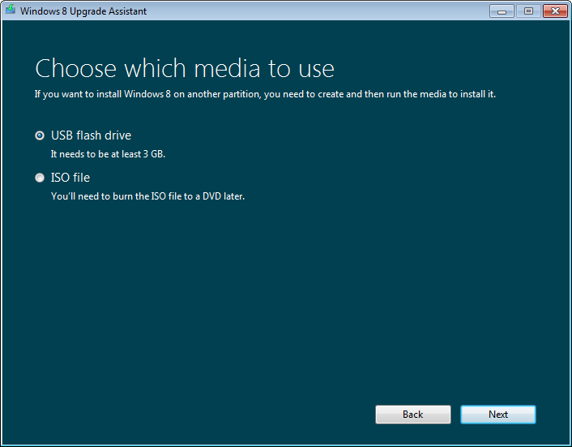

Figure : Web Setup―create media

#### USB Flash Drive

The USB flash drive choice leads to a selection screen where you can pick the flash drive to use.

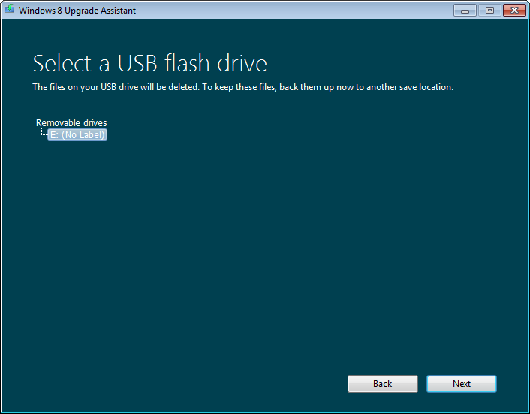

Figure : Web Setup―USB drive 1

Next comes a warning that the flash drive will be formatted.

The copy process proceeds with an indication of percent completion. When the USB flash drive copy process is complete, you will see the final message shown below. It is important to write down this product key, as this will need to be entered manually during setup.

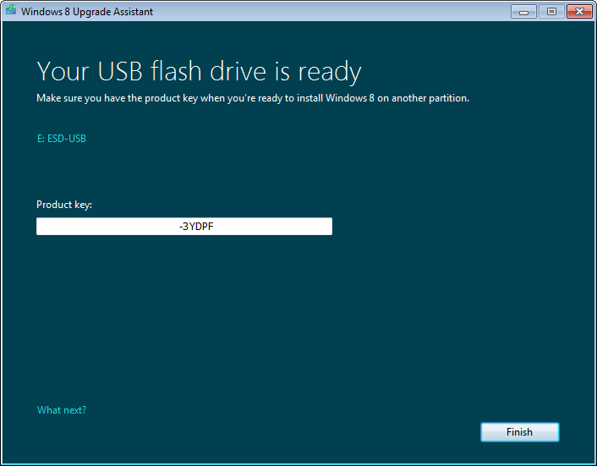

Figure : Web Setup―USB drive 2

#### ISO File to Burn to a DVD

The ISO choice opens a **File Save** dialog box in which you can choose the location to save the file. By default, it is named Windows.iso and saved in your Documents library.

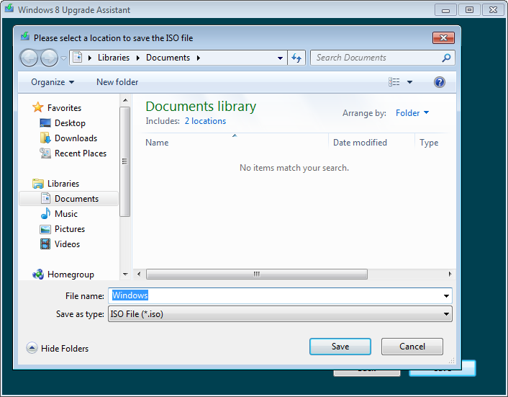

Figure : Web Setup―ISO save location

As with the USB flash drive, when the ISO file creation process is complete, the product key is shown, as you will need the key when you boot from the media to perform the installation.

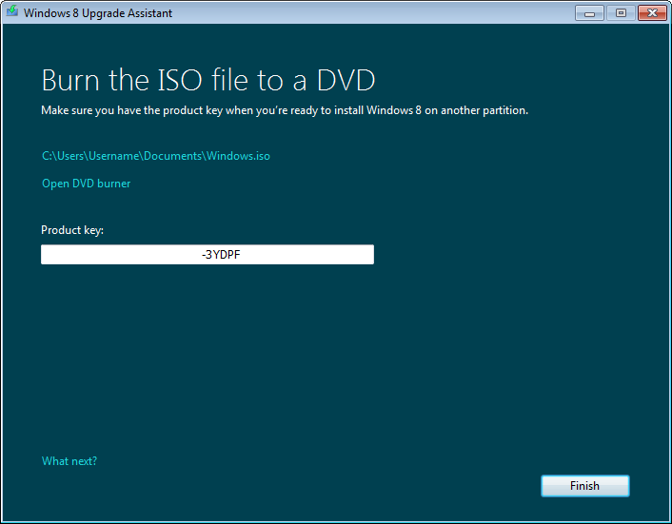

Figure : Web Setup―ISO complete

This ISO file can be burned to DVD using any capable DVD burning software. Within Windows 7, this can be done using the built-in ISO burning utility by clicking the **Open DVD burner** link. This opens the burn interface, as shown below.

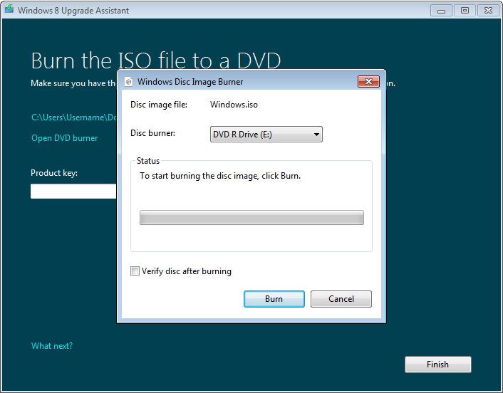

Figure : Web Setup―ISO burn

### Key Web Setup Paths

Web Setup uses the following file system paths:

* **%UserProfile%\Desktop -** A shortcut is created on the user’s desktop. This can be used to resume Web Setup, if it is in progress, or start the installation if Web Setup was completed.
* **%LocalAppData%\Microsoft\WebSetup -** This path contains the Web Setup engine and support files, such as the Panther folder, which contains the log files for Web Setup.
* **C:\Windows\ESD -** This is the location where the complete installation source is located when Web Setup is complete.

## Troubleshooting

Troubleshooting topics related to Windows 8 setup are discussed below. Troubleshooting and logging is largely the same as with Windows 7 setup. The major exception is Web Setup. Troubleshooting for Web Setup is discussed below, along with several other troubleshooting topics.

### Web Setup Troubleshooting

Troubleshooting for Web Setup depends on the stage of the Web Setup where the issue occurs.

For any stage, you can review the log files for clues. The log files are located in this folder until the main Windows setup process starts: %LocalAppData%\Microsoft\WebSetup\Panther. Errors during key acquisition or download should be in the Setuperr.log. Troubleshoot as you would similar issues outside the context of setup.

**Note:** Once Web Setup is complete and the main setup engine (install.exe) has started, log data is saved to the same locations as on Windows 7. This includes the Web Setup log entries, which are moved to the main setup log.

#### Check Compatibility

If you encounter an issue during the initial compatibility check, consider the following actions:

* If there is a compatibility issue flagged in the report, Web Setup can simply be closed and action can be taken on the PC to resolve the concern. Then, restart the Upgrade Assistant to continue.
* If there is a problem completing the compatibility check, there may be issues on the PC that would interfere with setup. Consider simplifying the hardware configuration, performing a clean boot, or other troubleshooting to remove potential problem software on the PC.

**Important:** If the Upgrade Assistant determines that the PC is not compatible with Windows 8, setup will not proceed. This is a good thing, as it can help prevent a purchase of Windows 8 for a PC that is not compatible.

#### Purchase

Customers may report two main types of purchase issues:

1. Purchase done within the Upgrade Assistant interface:
   1. This is supported by Microsoft. For regions where there is a Microsoft Store online, it is generally this support team who can help assist customers. Support information is provided on the Microsoft.com page from which the customer started their purchase.
   2. If a customer is asking for general assistance in stepping through the purchase process, information in this training may help you guide them in their choices.
2. Purchase done from an online store and fulfilled via download in the Web Setup interface:
   1. If a customer is going through purchase steps like product selection, add to cart, and payment on a web page, support would be provided via the retailer.
   2. Microsoft can help assist customers once the purchase is complete and Web Setup is initiated to complete the download.

If a customer needs purchase-related assistance after completing the purchase, such as questions about refunds, order redemption, exchanges, etc. the best source of information will be in the receipt email or the retailer web site.

#### Product Key

**Important:** Once the product key has been retrieved and the download started, do not re-download the Web Setup tool from the web and run it on the PC. This will create a new temporary folder, replacing the saved purchase and key information. If you need to re-start Web Setup, use the “Install Windows” or “Download Windows” shortcut on the desktop.

Customers may need assistance with the product key in these scenarios:

* Product key was not written down, is now needed to complete setup: If this happens try the following:
  + Recommend using the purchase receipt email to get the product key.
  + Go through the Media Creation steps to create an ISO file. When the ISO file creation is complete, the product key is displayed.
* Web Setup was restarted or temporary folder overwritten, losing purchase context before completing download: If this happens try the following:
  + Recommend using the purchase receipt email to get the product key.
  + Refer the customer to the retailer for assistance if the email has been lost. If the retailer is Microsoft, the Microsoft Store support team or Customer Service will be able to assist the customer by resending the receipt email with the product key.

#### Download

Download issues will generally manifest with one of the following symptoms:

* Download progress stuck at 0% or another percentage for a very long period of time: Because Web Setup uses the BITS download engine, you can approach troubleshooting for download issues as you would Windows Update download errors. The percentage at which a failure happens will vary depending on the issue, and also depending on the specific version and language of Windows being downloaded.
* Error message: “We can’t connect right now.” To troubleshoot this, verify Internet connectivity and troubleshoot any issues found. This could be a transient error related to an issue on the servers. Retry later.
* Error message: “Download did not complete successfully.” This can be caused by a previous download attempt that was ended unexpectedly, such as by ending the process or restarting the system.
* Download interrupted: A customer may report that something interrupted the download, and they may be unsure of how to proceed. If the download process is interrupted for any reason you can use the Download Windows shortcut on the desktop to resume.

For the problem scenarios above, you will generally want to proceed using the following troubleshooting steps:

1. Was the download interrupted without an error? If it was, locate the Download Windows shortcut on the desktop and use it to resume the download.
2. Is it a transient error? Recommend trying again later, unless the error has been shown a few times.
3. For other issues, restart the download:
   1. Close the Upgrade Assistant interface. It may take 2-3 minutes for the process to end, even after the window closes. This should only be an issue if you try to restart Web Setup or delete the Web Setup folder soon after closing the window.
   2. Clear the BITS queue to start a fresh download. This can be done with either of the following methods:
      1. BITSAdmin command run from an Administrator command prompt:

bitsadmin /reset /allusers

* + 1. Run the FixIt solution in Knowledge Base article 971058. See the detailed steps in that article for BITS-related commands.

1. If there is still a download-related issue, treat it as you would any download failure related to Windows Update.

**Important:** Do not delete the Web Setup temporary directory in %LocalAppData%\Microsoft\WebSetup. This folder contains reference information used to resume the download and retain purchase context so that the customer is not asked for payment information again.

#### Start Setup or Create Media

If a customer is having an issue at this stage of Web Setup, consider the following:

* Is **Install now** failing?
  + Use the **Install Later** option to pause Web Setup. Then restart the PC and use the Install Windows shortcut on the desktop.
  + If the installation continues to experience issues, it may be best to create installation media and perform a clean install. Setup is not recommended on a Windows installation where there are current issues – it can lead to worse issues during the upgrade.
* Issues burning the ISO to a DVD?
  + DVD burning issues should be handled based on the customer’s current Windows version or DVD burning software. If a customer is running Windows 7, be sure to try using the native ISO burning capability. If there is a problem running a third-party burning product, check for known issues and help the customer find an alternative or a way to get assistance on the burning product.
* Issues creating a USB installation source?
  + Check the attributes of the USB flash drive:
    - Minimum 3 GB
    - Maximum 32 GB, as it is automatically formatted FAT32 by the Upgrade Assistant
  + Try formatting the USB flash drive with the FAT32 file system in Windows Explorer and then copy a few test files to it.
  + Test on a different USB port. If connecting to the front of a desktop PC, try using a port on the back.
  + Test with a different flash drive.

### Troubleshooting Other Issues

The troubleshooting steps you use for Windows 7 installation issues generally apply for Windows 8. Given the improvements in Windows installation with this release, you can expect to find the following changes to the issues and troubleshooting you encounter.

#### Media Issues

The errors related to bad media, such as DVD driver errors and 0x80070017 errors, and hangs during setup should be less common with the use of Web Setup.

If you see these issues when a customer has burned a Windows 8 DVD, it still relates to issues with the media. Recommend using the Web Setup process to install, where possible. It provides automatic download verification and repair.

If Web Setup is not an option and the customer needs to download an ISO file and burn media, check the integrity of the burned media to ensure that there was not an issue in download or burning.

#### Product Key Issues

Windows 8 does not prompt for a product key in several cases where Windows 7 did, as it can receive the key automatically from Web Setup, or from the OEM Windows 8 PC BIOS during a reinstall. In cases where the key is not provided automatically, Windows 8 requires you to enter a key during Setup. These changes make it much less likely that you will encounter issues related to a mismatch between the key and the product installed.

Error code 0xC00F061 is one example of this – Setup on Windows 8 requires the key, so a mismatch during activation is unlikely. This does not eliminate the underlying issue when you want to install, but it ensures the install steps proceed along a supported path.

If you are assisting a customer with an issue entering the key during Setup, proceed by verifying the key, and ensuring that it matches the installation media.

#### Processor Compatibility Issues

The new processor requirements in Windows 8 could lead to questions from customers. There is not a workaround to install Windows 8 on a PC that does not meet the CPU capability requirements.

If for some reason Setup does not block installation on a PC with an incompatible CPU, you can expect to see the following STOP error:

STOP 0x0000005D UNSUPPORTED_PROCESSOR

If this is encountered during an upgrade, the rollback process should return the PC to Windows 7. If it is encountered during another type of installation, it would be best to return the PC to its previous Windows version using the Windows.old folder.

You can also recommend that NX be enabled in the BIOS configuration, if possible. This should permit Windows 8 to start. If a customer needs assistance determining how to enable NX, they should consult with the PC manufacturer.

#### Device and Driver Issues

These were often related to drivers migrated from the previous Windows installation. This type of issue could appear on Windows 7 as one of the following symptoms:

* Hangs late in Setup, particularly at 62%, during an upgrade installation.
* Reboot loop
* Hangs at “Completing installation”

Windows 8 no longer shows the same style of progress tracking, so these issues can show different symptoms. On Windows 8, such issues are more likely to show one of these symptoms:

* Hang during “Getting devices ready”
* Hangs at “Completing installation”

Troubleshooting for these issues remains the same on Windows 8 – after rollback, focus on simplifying the hardware configuration and uninstalling unneeded drivers in Device Manager. If upgrade continues to fail, Windows 8 provides migration options that can help us get customer’s PCs installed to Windows 8 with their files and user accounts.

### Upgrade Rollback

Windows 8 upgrade installation provides a rollback capability, just as was present with Windows 7 and earlier. The rollback feature is initiated automatically in the event of an issue, when both of the following are true:

* The user selected the installation option **Windows settings, personal files and apps**.
* A failure occurs during installation, prior to the Windows Welcome phase of Setup.

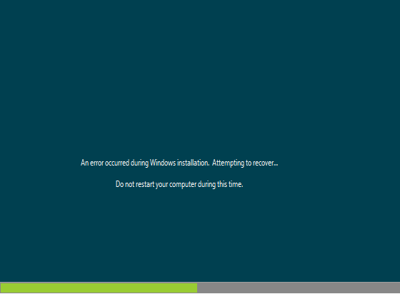

Figure : Upgrade rollback

Rollback is most commonly initiated during device installation, due to a problematic driver or device, or while Setup is restoring user files and settings.

**Note:** When you choose this installation option, there is no uninstall available once setup is complete.

### Choosing Migration Specifics

Some customers may want to choose which elements of their configuration are migrated to Windows 8. Using the **What do you want to keep?** options in Setup does not give users the chance to select specific user accounts, paths, setting types, and other detailed options. If a user prefers to choose their migrated elements more specifically, they can still use Windows Easy Transfer (WET) with the same experience as was provided in Windows 7.

To do this, run \support\migwiz\migsetup.exe from the Windows 8 installation source. This will enable the user to gather the specific data and settings needed from the previous Windows installation or old PC.

### Migration Failures

If a customer reports that Windows 8 Setup did not preserve files, settings, or apps as they expected it should, you can use the Windows.old folder as a source for information or recovery. You can do this to a much greater degree than with Windows 7 Setup due to the increased usage of Windows.old in Windows 8.

Windows 8 preserves the previous Windows installation in a Windows.old folder, regardless of the migration method selected. This means that you can generally recover the previous installation by restoring the contents of C:\Windows.old to the root of that drive.

This also gives support a significantly simplified ability to help recover missing data files after setup was run, particular after an upgrade – a full migration.

#### Windows.old Scheduled Task

There is one change to the way that the Windows.old folder is managed in Windows 8, compared with Windows 7. On Windows 8, when Install.exe creates a Windows.old folder, there is a schedule task added in the new Windows installation. This schedule task, SetupCleanupTask, removes the Windows.old folder contents when either of the following are true:

* It is 28 days since Windows was installed.
* The Windows drive has less than 10 percent free space.

When this action is taken, subfolders are removed, with the exception of \Windows.old\Users. This folder is not deleted by the schedule task, keeping user files intact.

If you want to remove the remaining contents of this folder, or if you want to remove Windows.old prior to this schedule task executing, you can use the **Previous Windows installation(s)** option in Disk Cleanup, as on Windows 7.

## Lab: Install Windows 8

This lab explores Windows 8 installation.

#### Expected Time for This Lab

This lab takes approximately 90 minutes to complete.

#### Requirements

To perform this lab you will need the following:

* A PC with Windows 7 Home Premium, Professional or Ultimate installed
* Windows 8 Release Preview installation media
* Internet Connectivity

### Exercise: Upgrade

1. Create user data and an app to migrate:
   1. Create a data file named datafile.txt in the Documents library or My Documents folder for your user account.
   2. Install Microsoft Security Essentials.
   3. Add a favorite in Internet Explorer®.
   4. Install another web browser, such as Chrome, Firefox, or Safari.
   5. Add a favorite/bookmark in the other browser.
2. Start Windows 8 Setup within Windows, using installation source files on your PC or a DVD or USB flash drive provided by your instructor.
   1. Product key for the Release Preview: TK8TP-9JN6P-7X7WW-RFFTV-B7QPF
3. Follow the path to perform an upgrade installation and watch for any potential issues or points where customers may have questions.
   1. Watch for and note any compatibility warnings.
4. When the upgrade is complete, check the following:
   1. Check for your data file. Is it still present where you expected to find it?
   2. Open an Administrator CMD window and run the following commands to search for any other copies of that data file on the drive:

cd\

dir datafile.txt /a /s

* 1. Were other copies found? Where and why?
  2. Is Microsoft Security Essentials still installed? Why or why not?
  3. Check Internet Explorer for that favorite entry you created. Is it still present?
  4. Check for the other browser and the favorite/bookmark you created. Are they still present?

1. If any elements of the configuration are missing, form an action plan for restoring them.
2. Discuss your results and action plan with other members of the class.
3. If there are a variety of potential solutions, try one and discuss your results with the class.